

SUCCESS THROUGH PARTNERSHIP



SYSTEM INTEGRATOR FOR TIME OF DAY (TOD) RATE CHANGE AUTOMATION

April 27, 2017

FOREWORD
This proposal has been prepared by HCL America, Inc. (HCL), for the sole use of Sacramento Municipal Utility District (SMUD).
The contents of this document shall remain the confidential and proprietary property of HCL. The data contained in this document shall not be disclosed and shall not be duplicated, used, or disclosed in whole or in part for any purpose without the prior written permission of HCL. The information contained herein may be preliminary and is subject to change. The offer or subsequent provision of the services described in this document shall be subject to a mutually agreed and executed contract.
HCL warrants that to the best of their knowledge those who prepared this response have taken all reasonable care in preparing it, have made all reasonable enquiries to establish the veracity of the statements contained in it and believe its contents to be true. (HCL cannot however warrant the truth of matters outside of its control and accordingly does not warrant the truth of all statements set out in this document to the extent that such statements derive from facts and matters supplied by other persons to HCL. The statements in this document are qualified accordingly.)

VALIDITY
This proposal and all information contained within are valid for a period of 90 days from April 27, 2017.

HCL CONTACT
Name | Veronica Bradley
Address | 330 Potrero Avenue  Sunnyvale, CA 94085
Email | Veronica.Bradley@HCL.com
Tel | 509-855-8952

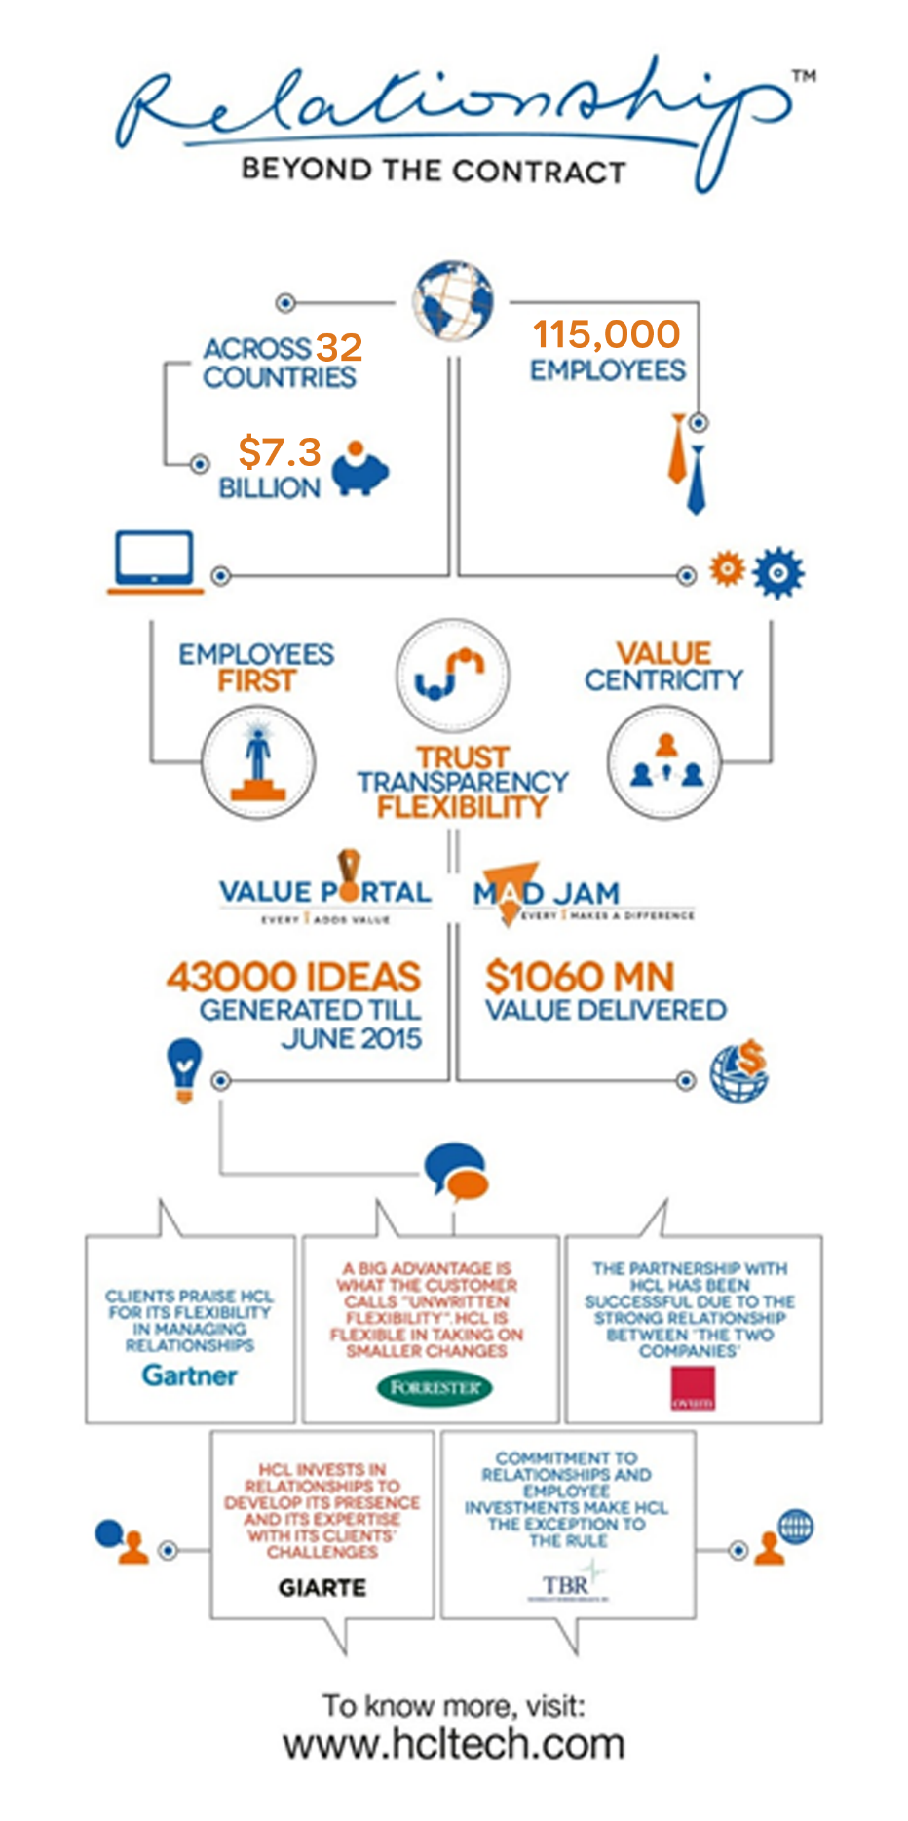

TABLE OF CONTENTS

Executive Summary 1
6 PROPOSAL REQUIREMENTS 3
6.1 PROPOSAL AGREEMENT NO. 170061.MP 3
6.2 SAFETY COMPLIANCE CERTIFICATE 5
6.3 NONCOLLUSION STATEMENT 6
6.4 PUBLIC RECORD INDEMNITY AGREEMENT 7
6.5 PROMPT PAYMENT PROGRAM 8
6.6 SEED PROGRAM SMALL BUSINESS DECLARATION 9
6.7 DESIGNATION OF PRIME CONTRACTOR, SUBCONTRACTORS AND SUPPLIERS 10
6.8 DETAILED PROPOSAL 12
6.9 BID SCHEDULE 51
Appendix 53
Appendix 1: Acknowledgement of Addendums 53
Appendix 2: Resumes 53
Appendix 3: HCL Exceptions Section 78

Executive Summary
HCL would like to thank SMUD for giving us the opportunity to participate in the SI for TOD Rate Change Automation initiative. In the spirit of building on our past successes, we have crafted a solution and approach built on flexibility through trust and transparency and we are pleased to submit our response.
HCL understands SMUD is in the process to transition to Time of Use (TOU) standard rate billing for residential customers between 2018 – 2019. In preparation for the transformation, SMUD is seeking a System Integrator (SI) to lead SMUD in the design, configuration, integration, development, testing, and deployment of a new automated rate change solution with self-service functionality. The solution will include SAP-based workflow management processes, rate change business rules, and repository solutions leveraging AMI-MDUS and other SAP Modules if applicable within SMUD’s current environment. HCL also understands the solution will serve as the driver, repository, and governance processes which currently reside in multiple systems including, SAP, spreadsheets and SharePoint, to serve as our system of record, customized to meet the needs of SMUD and replace existing manual processes.

Proven Experience with SAP and the Utilities Industry
For over 20 years, HCL has partnered with SAP and has a proven track record of delivering a best-practices approach to successfully implementing over 250 SAP upgrade projects globally; including the World’s largest single instance upgrade project. HCL America – Utilities has an estimated 600 dedicated and experienced consultants focused on SAP.
HCL America – Utilities represents one of HCL’s strongest vertical industries and is servicing over 25 Utilities in North America. HCL Utilities is dedicated to delivering innovative solutions and our experience with SAP has allowed us to refine our offerings and approaches to benefit our Utility clients. By developing tools, templates, and solutions for the Industry, our Utility clients have realized both tangible and intangible benefits and value behind strategic programs and projects.

Experienced and Familiar Team
Given HCL’s understanding of SMUD’s initiative and environment, HCL assembled a talented team with in-depth experience working with utility organizations to improve their business processes through utilization of SAP solutions. In addition, every consultant and SME on the team possesses extensive SAP billing process and complex customization project experience and has worked with Utilities in North America to address these types of opportunities. While the entire HCL team planned to be on the project team is stellar, we have identified a Functional Lead with SMUD project experience and incredible delivery results: Viji Manickam. Along with Viji, HCL has identified a Billing SME with recent, related project experience at Consumer’s Energy: Jamparaju Nammi. HCL is confident the combination of these two experts, along with the remaining team, we will achieve the business objectives and system requirements to deliver an on-time and on-budget project. HCL consultants proposed for SMUD have experience with full-cycle SAP IS-U or CR&B implementations. The team also has experience with SAP solultions across the full spectrum, providing them with insights to SAP best practices and strategic roadmap decisions.
HCL has engaged with a SEED company to jointly-deliver a solution for SMUD. Based on our project experience at SMUD, HCL engaged TechNet to join the team. TechNet will provide some developers and will lead all of the testing activities. HCL feels this approach will benefit SMUD to ensure we have ‘fresh eyes’ on the testing efforts.

Best-Practices and Strategic Approach
HCL has extensive implementation experience in the utilities industry, and the methodology used in our implementation projects has been continually revised to incorporate lessons learned.
From a project standpoint, it is our experience and firm belief, that successful projects come from successful collaboration between SI and client. The ‘One Team’ approach, where all team members work together, bringing their particular skills and an open mind to the table, is key to a successful outcome. Communication and collaboration are critical to the success of a project.
HCL has a proven framework and methodology for the management of projects through our Integrated Global Delivery Model (iGDM). It offers the best methodologies, templates, tools and a project management framework in the organization in a structured way.
iGDM is supported by a comprehensive project management toolset called APSE (HCL Project Support Environment). APSE has been specifically designed to manage SAP implementations providing a common repository for the management of design artifacts, deliverables, risks, issues, status reports, design decisions, project reporting, etc.
HCL feels the combination of our talented team, SAP project and implementation experience, and our proven framework and methodology to manage SAP projects with our unique tools will benefit SMUD in achieving the business objectives and system requirements for the TOD rate change automation project. HCL values the opportunity to present SMUD with a fixed price solution for $3.092M – USD. We feel confident to deliver this solution with TechNet in 11 months. Our team appreciates the opportunity to present our proposal and is available to disucss the content and costs.

PROPOSAL REQUIREMENTS
TO FACILITATE SMUD’S PROPOSAL REVIEW PROCESS, IT IS REQUIRED THAT EACH PROPOSAL CONTAINS ALL OF THE INFORMATION WITHIN THIS SECTION AND IS ORGANIZED IN THE SEQUENCE THAT THE ITEMS APPEAR IN THIS SECTION.
THE PROPOSER SHALL SUBMIT ONE (1) COPY OF THE PROPOSAL IN HARD COPY AND ONE (1) IN ELECTRONIC (ON FLASH DRIVE) FORMAT.

ADDITIONALLY, THE PROPOSER SHALL SUBMIT ONE HARD COPY JUST OF SECTION 6.8, DETAILED PROPOSAL, AND ONE COPY OF THAT FILE ON THE FLASH DRIVE.

PROPOSALS SHALL BE PRINTED ONE-SIDED, 8-1/2 X 11” SIZE AND EASILY REMOVABLE FROM ANY BINDING -- E.G. no glued or spiral binding.
SMUD will provide an electronic copy of the Proposal Forms in MS Word 7.0 (or newer) which contains fill-in fields. The document is labeled RFP Proposal Fill-in Forms. Proposers may use the Forms provided to submit Proposals. Please provide responses to all questions in the block (fill-in fields) following every question. The fill-in fields will expand to accommodate your answer. Pictures, charts and graphs may also be inserted into the fill-in fields or may be attached as a separate documents if necessary
Note: The content of the RFP Proposal Fill-in Forms is identical to that posted in Adobe format on the EBSS Web site. Page numbering may vary when complete as a result of the fill-in-fields.

PROPOSAL AGREEMENT NO. 170061.MP
PROPOSAL AGREEMENT: In compliance with Request for Proposal No. 170061.MP , SYSTEM INTEGRATOR FOR TIME OF DAY (TOD) RATE CHANGE AUTOMATION, the undersigned hereby proposes and agrees to provide the services described, at the rates and dollar limits defined in the Proposal Rate Schedule attached hereto.
It is understood that this proposal constitutes a firm offer that cannot be withdrawn for ninety (90) calendar days after the submission date for the proposals.
The undersigned certifies that he/she has examined and is familiar with the content of this Request for Proposal; also that he/she has checked all the figures shown in the proposed Rate Schedule and other attachments hereto and understands that the Sacramento Municipal Utility District will not be responsible for any errors or omissions on Contractor's part in preparing this proposal.
The undersigned further agrees, if awarded the contract, that he/she will commence the work within the time set forth and will perform the work in accordance with the contract documents attached to this Request for Proposal.
Attached hereto and made a part thereof by this reference are proposal forms pages 6-3 through 6-9, the Detailed Proposal and the Bid Schedule.
Company: HCL America, Inc.
Street Address: 330 Potrero Avenue
City: Sunnyvale State: CA Zip: 94085
Signed:
Print Name: Veronica Bradley
Title: Senior Regional Sales Director
Telephone: 509-855-8952 Fax:
Email: veronica.bradley@hcl.com Date: April 26, 2017

SAFETY COMPLIANCE CERTIFICATE
I, the undersigned,
(Print Company Representative Name)
of
(Print Company Representative Title)
hereby certify the
(Print Company Name)
information contained herein and that undersigned is duly authorized to certify that:
- Contractor has an effective Injury and Illness Prevention Program which meets the requirements of all applicable laws and regulations, including, but not limited to, California Labor Code Section 6401.7. (This section does not apply if Contractor does not perform any work under this agreement within the State of California.) and
http://www.leginfo.ca.gov/cgi-bin/displaycode?section=lab&group=06001-07000&file=6400-6413.5
- Contractor agrees that it is fully responsible for the acts and omissions of its subcontractors and all persons either directly or indirectly employed by Contractor.
- The above-named person has the authority and responsibility for implementing and administering Contractor’s Injury and Illness Prevention Program.
IN WITNESS WHEREOF, the undersigned has executed this Safety Compliance Certificate under the penalty of perjury of the laws of the State of California on:

Signed:
Print Name:
Date:

NONCOLLUSION STATEMENT
TO BE EXECUTED BY PROPOSER AND SUBMITTED WITH PROPOSAL
I, am the
(Print Company Representative Name)

of
(Print Company Representative Title)
the party making the
(Print Company Name)

foregoing bid, that the bid is not made in the interest of, or on behalf of, any undisclosed person, partnership, company, association, organization, or corporation; that the bid is genuine and not collusive or sham; that the Bidder has not directly or indirectly induced or solicited any other Bidder to put in a false or sham bid, and has not directly or indirectly colluded, conspired, connived, or agreed with any Bidder or anyone else to put in a sham bid, or that anyone shall refrain from bidding; that the Bidder has not in any manner, directly or indirectly, sought by agreement, communication, or conference with anyone to fix the bid price of the Bidder or any other Bidder, or to fix any overhead, profit, or cost element of the bid price, or of that of any other Bidder, or to secure any advantage against the public body awarding the contract of anyone interested in the proposed contract; that all statements contained in the bid are true; and, further, that the Bidder has not, directly or indirectly, submitted his or her bid price or any breakdown thereof, or the contents thereof, or divulged information or data relative thereto, or paid, and will not pay, any fee to any corporation, partnership, company association, organization, bid depository, or to any member or agent thereof to effectuate a collusive or sham bid.

Signed:
Print Name:
Title:

PUBLIC RECORD INDEMNITY AGREEMENT
(“Proposer”) shall indemnify, defend and hold SMUD,
(Print Company Name)
its directors, officers, agents, and employees (collectively, “Indemnitees”) harmless against all claims or causes of action brought against Indemnitees seeking to cause the release or disclosure of Proposer’s Proposal and related materials submitted to Indemnitees in response to SMUD Request For Proposal No. 170061.MP , SYSTEM INTEGRATOR FOR TIME OF DAY (TOD) RATE CHANGE AUTOMATION.
In the event Proposer fails or refuses to indemnify or defend Indemnitees upon a timely request as provided hereunder, Proposer shall unconditionally waive all claims against, completely release and forever discharge Indemnitees from any and all claims, damage, loss, expense and liability Proposer may incur arising from or in any way connected to Indemnitees release of Proposer’s Proposal and materials related thereto.
It is agreed that in the event of any litigation arising hereunder, the Proposer at the request of SMUD shall submit to the jurisdiction of any court of competent jurisdiction within the State of California and will comply with all requirements necessary to give such Court jurisdiction, and that all matters arising hereunder shall be determined in accordance with the law and practice of such court. It is further agreed that service of process in any such litigation may be made in the manner provided for in Section 415.40 of the California Code of Civil Procedure or in any other manner provided for in said code for service upon a person outside the State of California.
ACCEPTED FOR PROPOSER
Company:
Signed:
Print Name:

PROMPT PAYMENT PROGRAM
SMUD has a prompt payment program for small businesses which are certified by the State Department of General Services.
Under the program, SMUD will guarantee payment of invoices within 20 calendar days from the date of inspection and acceptance by SMUD or the date correct invoices are received, whichever is later.
If SMUD fails to meet the 20 calendar days payment guarantee, the small business will be paid interest on the unpaid invoice at prime plus 2% APR. Late interest payments, if applicable, will be made without an additional invoice from the small business.
To participate in this program, please indicate “prompt payment” below and provide evidence of certification with your bid.
Bidder is eligible for, and is requesting, a prompt payment program:
YES NO
PROPOSER:
Company:
Signed:
Print Name:

SEED PROGRAM SMALL BUSINESS DECLARATION
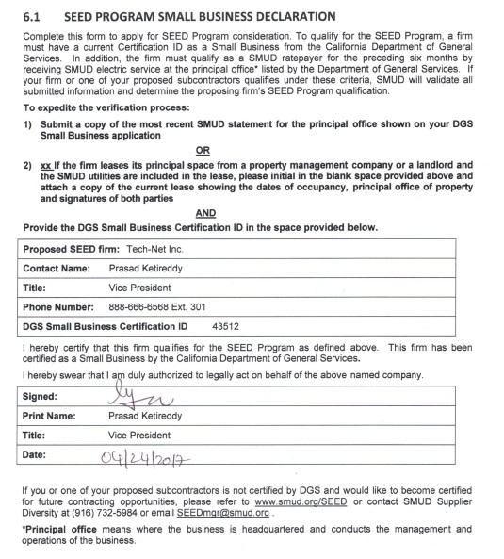

DESIGNATION OF PRIME CONTRACTOR, SUBCONTRACTORS AND SUPPLIERS
(TO BE COMPLETED BY ALL BIDDERS/PROPOSERS)
The following are the names and business locations of the prime contractor and all subcontractors who will perform work or labor or render service to the Proposer in or about the work, or who will specially fabricate and install a portion of the work or improvement according to detailed drawings contained in the plans and specifications (as applicable) together with a statement of the portion of the work to be done by each subcontractor.
SEED Program - The Proposer may only count toward its SEED Program subcontracting credit those expenditures to subcontractors or contractors under a subcontractor that perform a commercially useful function. In addition, each contractor or subcontractor claiming SEED Program qualification shall complete the SEED PROGRAM SMALL BUSINESS DECLARATION.

 | Firm  (Name and Address) | Work, Material or Service (Provide Brief Description) | Supplier Diversity/SEED Program Status | Percent (%)  (Of Total Proposal Price) | Dollar Amount  (Of This Firm's Work, Material or Service)
1. | PROPOSER/PRIME CONTRACTOR  Name: HCL America, Inc.  Address: 330 Potrero Ave  City, State, Zip: Sunnyvale, CA 94085  Primary Contact: Veronica Bradley  Phone # 509-855-8952 | SAP consulting services – technical and system. | SEED Qualified  Yes No | 82.54 %  of Total Proposal | $2,552,000  Amount of  Total Proposal
2. | SUBCONTRACTOR  Name Tech-Net  Address101 Parkshore Drive, Suite 100  City, State, Zip Folsom, CA 95670  Primary Contact Prasad Ketireddy  Phone # 888-666-6568 Ext. 301 | Tech-Net will provide complementary consultants to HCL America, including Developers to perform development tasks within the system to support the process (enhancements, interfaces etc.); and,  Testers to support the creation of test plans, execution, and other related tasks. | SEED Qualified  Yes No | 17.46 %  of Total Proposal | $540,000  Amount of  Total Proposal
DESIGNATION OF PRIME CONTRACTOR, SUBCONTRACTORS, AND SUPPLIERS
(Continuation Page; may be duplicated as needed)

 | SUBCONTRACTOR  Name  Address  City, State, Zip  Primary Contact  Phone # |  | SEED Qualified  Yes No | ___ %  of Total Proposal | $_________  Amount of  Total Proposal
 | SUBCONTRACTOR  Name  Address  City, State, Zip  Primary Contact  Phone # |  | SEED Qualified  Yes No | ___ %  of Total Proposal | $_________  Amount of  Total Proposal
 | SUBCONTRACTOR  Name  Address  City, State, Zip  Primary Contact  Phone # |  | SEED Qualified  Yes No | ___ %  of Total Proposal | $_________  Amount of  Total Proposal
 | SUBCONTRACTOR  Name  Address  City, State, Zip  Primary Contact  Phone # |  | SEED Qualified  Yes No | ___ %  of Total Proposal | $_________  Amount of  Total Proposal
 | SUBCONTRACTOR  Name  Address  City, State, Zip  Primary Contact  Phone # |  | SEED Qualified  Yes No | ___ %  of Total Proposal | $_________  Amount of  Total Proposal

DETAILED PROPOSAL

Evaluation Criteria 1 Mandatory Pass/Fail Requirements
Questions in the mandatory section require signature as verification by proposer of their ability to meet each requirement. Only those proposals which meet all mandatory requirements will be we considered.
THE ITEMS IN THIS SECTION WILL BE EVALUATED ON A PASS/FAIL BASIS. ONLY THOSE PROPOSALS MEETING ALL OF THE MANDATORY REQUIREMENTS WILL BE CONSIDERED. IF IT IS DETERMINED THAT ONE OR MORE OF THE FOLLOWING MANDATORY REQUIREMENTS ARE NOT MET, THE SUCCESSFUL PROPOSER WILL FAIL THIS SECTION AND THE PROPOSAL WILL BE CONSIDERED NON-RESPONSIVE.
  - Proposer must have implemented three (3) relevant SAP rate-related billing process solutions or complex customizations within a minimum of three (3) North American companies production environments including integrations with SAP ECC 6.0

  - Proposers’ core team members must each have a minimum of three (3) full cycle implementations or upgrades (project prep to go-live) for their area of SAP expertise for this project’s scope.

  - The project must be run, managed, developed, tested and implemented from SMUD’s headquarters located in Sacramento, California. SMUD requires the majority of project work to be done on-site in Sacramento due to the size, complexity of the project, large amount of back-office system integration work with SAP, and for knowledge transfer with the SMUD functional and technical staff. A minimal number of off-site resources will be considered.

  - Proposers must obtain a MINIMUM score of 12 points in Section 3, the
Experience, Methodologies and Implementation capability to pass on to Section 4, the Functional and Technical Requirements evaluation and proposers must obtain a MINIMUM score of 24 points in Section 4, the Technical Requirements to pass on to Section 5, the Commercial Terms and Compliance evaluation in Section 5. PROPOSAL EVALUATION CRITERIA.

Proposal meets all mandatory requirements:

Signature:

Print Name: Veronica Bradley

Date: April 26, 2017

Evaluation Criteria 2 SEED Program Evaluation Points
Ten evaluation points will be awarded to SEED qualified prime Proposers. Non-SEED prime Proposers will receive up to ten evaluation points on a pro-rata basis for proposing at least 20% subcontracting which utilizes SEED subcontractors. Details are in the Supplier Education & Economic Development section of this document.
If submitting a proposal with SEED subcontracting participation, Proposer shall describe in detail the SEED subcontractor’s scope of services. The Proposer shall further provide the % and the total amount of the SEED participation in the Prime Contractor, Subcontractor and Suppliers Form. Proposer who is awarded the contract shall provide SMUD with the SEED subcontractor actual spend via quarterly reporting of subcontractor invoices and payment documentation.

Evaluation Criteria 3 Proposer's & Project Team’s Experience, Methodologies, Implementation Capability
This Section must demonstrate that your organization has the experience and capability to provide the required software and services.
Background and Project Team Structure
- Please provide a list of three (3) former clients who received services from the Proposer for projects of a similar nature and size. This listing shall include names of client representatives and their phone numbers. Proposers are responsible for ensuring the accuracy of the information provided. SMUD may consider a proposal non-responsive and disqualify the Proposer if SMUD is unable to reach a listed reference due to inaccurate or incomplete information. SMUD representatives may contact each reference for clarification and validation purposes.

References must be willing to discuss your services with SMUD staff during the evaluation process.
 | Reference 1 | Reference 2 | Reference 3
Company | National Fuel Gas Distribution Corporation | Washington Gas | Consumer’s Energy
Contact Name | Patrick Boyle | Lorey Hoffman | ChekTeck Poh
Title | General Manager, Information Services | CIO | Executive Director or IT
Phone Number | Client has requested HCL broker client reference call with SMUD | Client has requested HCL broker client reference call with SMUD | Client has requested HCL broker client reference call with SMUD
E-Mail | Veronica.Bradley@hcl.com | Veronica.Bradley@hcl.com | Veronica.Bradley@hcl.com
Date of implementation | May, 2016 – please confirm with the client | January, 2017 – please confirm with client | 2011 – please confirm with client

- Please provide a statement describing the origin, background, and size of the Proposer's company and Division or Department who will run this project.
Response:
Founded in 1976, HCL is one of India's original IT garage start-ups. HCL has a rich history of inventions and innovations ranging from an indigenously developed micro-computer at the same time as that of Apple, to the development of a fine grained UNIX multi-processor. HCL's R&D was spun off as HCL Technologies to mark its advent into the software services arena. During the past years, HCL has strengthened its processes and applied its know-how and developed over 40 years into multiple practices and business areas.
HCL is a $7.3-billion-dollar global technology and IT enterprise. HCL has grown organically and through acquisition to become a global enterprise with over 115,000 professionals. Its service mix includes application services (implementation and maintenance), engineering and R&D services, infrastructure services, and business services for the industries of manufacturing, financials, life sciences and healthcare, energy and utilities, and consumers.
HCL leverages its extensive global team of over 115,000 employees and a network of offices in 32 countries to provide holistic, multi-service delivery in key industry verticals.
HCL has the global experience with scale and process maturity to help IT leaders manage and govern business processes that proactively help align business level KPIs with IT SLAs.
A core business unit of HCL, and the business unit engaged in this response, is the Applications Business Unit, which provides customers with integrated transformational services for their applications portfolio. It has end-to-end capabilities in the ERP space including blueprinting, implementation and roll-out and support optimization. Accounting for $2.7bn in revenue with more than 41,000 employees representing 32 countries, the Applications Business Unit allows HCL to provide a broad range of focused application and business services, and the unique ability to seamlessly integrate multiple service lines as best suits our clients’ individual requirements. We combine this approach with in-depth expertise in major industries such as manufacturing, consumer services, financial services, life sciences, and public sector. We have structured our Applications Business Unit to help our clients realize maximum value through their IT investments.
Using our end-to-end IT capabilities — from systems integration to application maintenance and support — we deliver value-driven solutions designed to help our client maximize their return on investment, enhance business productivity and reduce the total cost of technology ownership.
Our specific strengths include:
- Business Transformation – Process improvements and organizational changes required to achieve new levels of business performance and a unique approach to benefits realization.
- Implementation – Includes global planning and roll out of large scale complex programs in a multi-vendor environment.
- Close Partnership – We are established partners with leading enterprise application providers—SAP, Oracle and Microsoft.
ALT ASM™ – Our alternate model of providing Application Support Management services that delivers significant savings and committed ongoing innovation and value add.
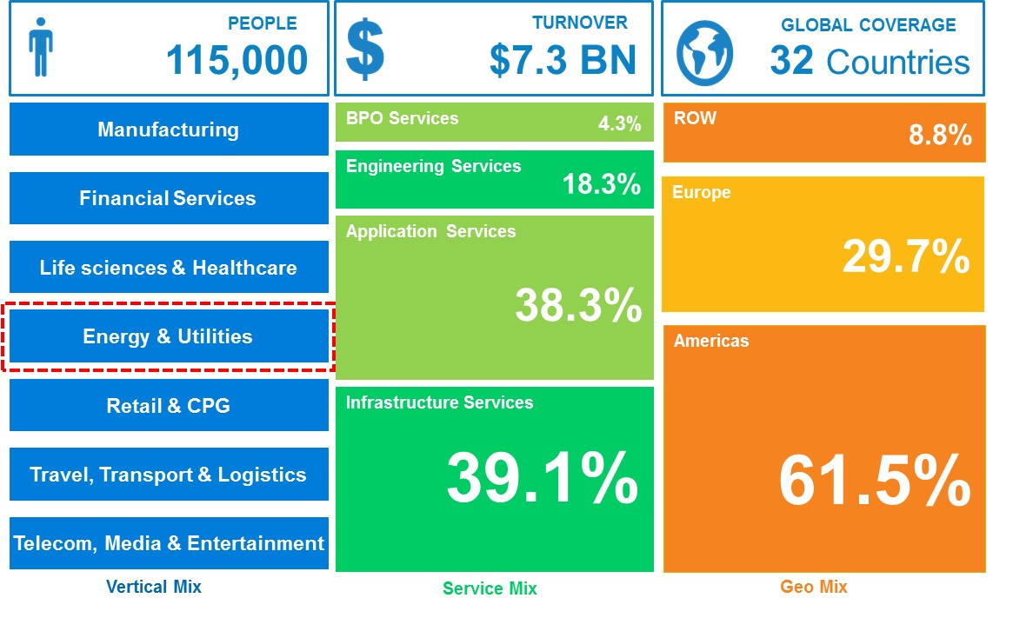
Figure 1: HCL Snapshot
HCL in Utilities:
HCL’s Utilities practice has grown both organically and through acquisition over the past two decades to provide a comprehensive and integrated offering across the following service lines, enabling true end-to-end technology and business process services for the industry.
Today, HCL supports 25 utility companies with over 21 million cumulative customers in North America for Infrastructure, Operations, Applications & Services out of our Global Delivery Centers using over 10,000 global consultants. HCL is the Data Center and Infrastructure Hosting Provider for seven utilities in North America. Additionally, HCL operates call centers and back-office for utilities from three different continents.
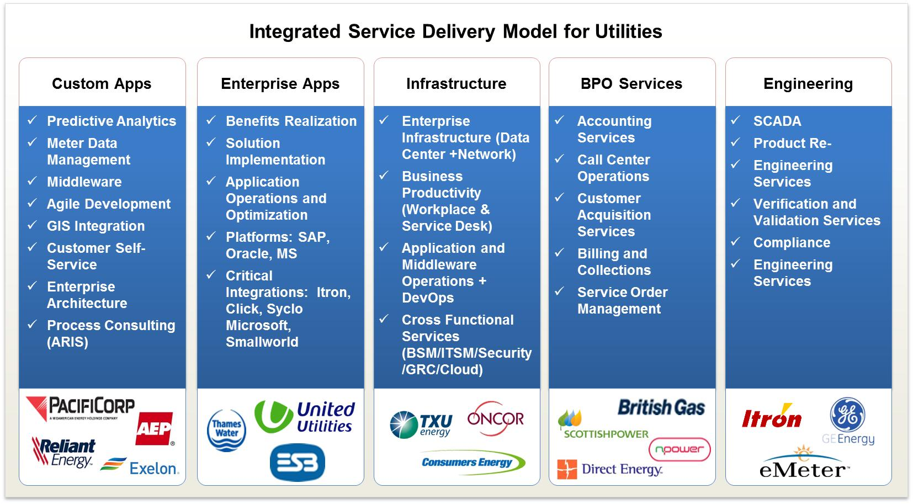
Figure 2: Integrated Service Lines

HCL and SAP:
- HCL is recognized as one of 14 Global SAP Partners
- HCL is certified as an SAP Value Management partner globally providing access to SAP’s library of business benefit case studies
- HCL operates its own business on a full complement of SAP’s Enterprise Solution
- HCL is a member of the SAP Utilities Lighthouse Council, which is charged with defining the direction for future development of the SAP Utilities solution. A key focus of the Lighthouse Council is developing the SAP solution to enable utilities to take full advantage of emerging Cloud, Smart Grid & AMI technologies.
- HCL continues to co-innovate with SAP specific to SAP CR&B / CRM, SAP AMI, and their partner network of MDUS providers.
In addition to HCL’s recognition as a strategic partner by SAP, HCL has also been recognized by leading analysts as leader in SAP services. HCL is one of only three companies to be in the top quadrant on each of the analyst reports (Forrester, Gartner and IDC). HCL has also demonstrated growth and improvement in all three analyst reports, and received a perfect 5 out of 5 from Forrester for Customer Satisfaction.

SAP in Utilities
HCL has partnered with SAP in the utility industry because of the depth of features, functions, and the ongoing commitment to provide and continually improve the applications required for business operations and transformation. HCL is dedicated to delivering innovative solutions and our experience with SAP has allowed us to refine our offerings and approaches to benefit our Utility clients. By developing tools, templates, and solutions for the Industry, our Utility clients have realized both tangible and intangible benefits and value behind strategic programs and projects.
As a leader delivering SAP solutions, HCL has successfully delivered 14 SAP ERP, 8 SAP EAM, and 36 CR&B implementations and modernizations for Utilities in North America.

- Please provide a description of the Proposer's and the proposed team previous electric utility experience as it relates to the Scope of Work.
Response:
HCL Utilities represents one of our strongest verticals with unparalleled experience across SAP. Our team is seasoned and each member possesses multiple years of extensive project implementations and enhancements.
The depth of our utility experience has allowed HCL to refine its fully configured SAP utility environment to include specific tools, templates, and pre-configured solutions. HCL has a group of utility SAP professionals dedicated to developing innovations to further enhance the SAP solution set for our customers. Thus far HCL has launched 5 major products and has several others incubating.
Our proposal leverages HCL’s knowledge of utilities’ best practices, our implementation accelerators, our transformation methodology, and a highly skilled team to provide SMUD with a solution to meet project objectives and business needs..
HCL has successfully delivered programs of a very similar scope to this program. Based on our team experience and expertise, HCL feels confident to deliver this project on-time and within the proposed costs – at budget.
Included below we have highlighted some of our electric utility experience with ERP, EAM and CIS projects:
Utility Name |  | Services  E – Electric  G – Gas  W - Water | SAP CIS | SAP ERP | SAP EAM
 | Tacoma Water, Tacoma Public Utilities and the City of Tacoma | E, W |  |  | 
 | Consumers Energy | E, G | ⁴ | ⁴ | ⁴
 | Sacramento Municipal Utility District | E |  | 
 | Rochester Public Utilities | E, W |  |  | 
 | Fortis BC | E, G | 
 | TXU Utilities | E |  | 
 | Arizona Electric Power Cooperative | E |  | 
 | Tampa Electric Company | E |  | ²
 | CPS Energy (Municipal Electric Utility in San Antonio, TX) | E |  | ²
** 2 – Optimized Solution as part of upgrade
3 – Blueprint or Management Consulting
4 – Enterprise Applications Support Only
The table below highlights additional HCL Electric Utility Experience outside of the SAP Applications scope.
HCL Electric Utility Customers |  | Services  E – Electric  G – Gas | Prime Contractor | HCL participation
 | CenterPoint Energy | E, G | Yes | Strategic Planning for Common CRM Platform across all business units.
 | Reliant Energy | E | Yes | Custom Applications development for Customer Services and Web Services
 | Oncor | E | Yes | Outsourced entire data center operations to HCL
 | Luminant | E | Yes | Outsourced entire data center operations to HCL

- Provide a corporate and project organization chart.
Response:
HCL America – Utilities is part of HCL Application and System Integration Services. Reporting directly to Ajit Kumar is Tony Calloway, VP of SAP Practice – North America. Bob Simpson, SAP Practice – Senior Program Director, reports to Calloway and will be responsible for the overall team assigned to SMUD. In addition to Bob Simpson, Veronica Bradley, Senior Regional Director – Utilities, will work with SMUD for overall account management activities and to ensure client satisfaction. Corporate and Project Organization charts are provided below.
Corporate Organization chart::
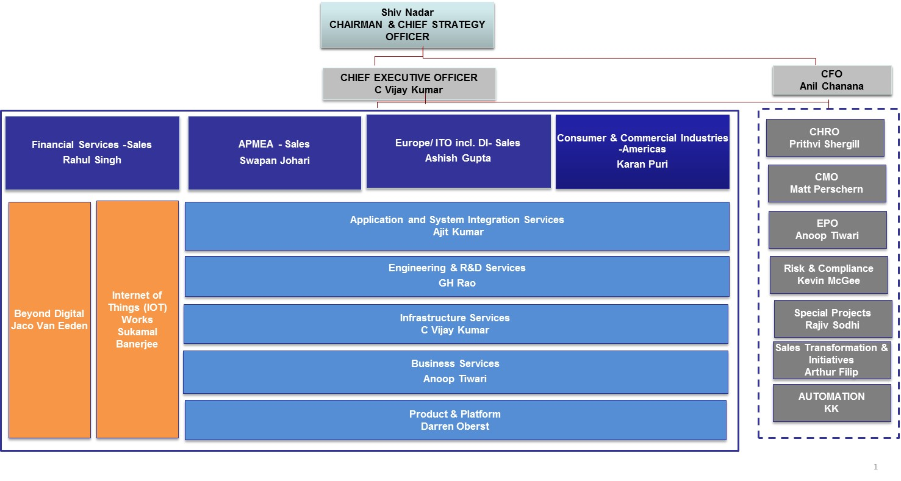
Figure 3: HCL Organization chart
Project Organization chart::
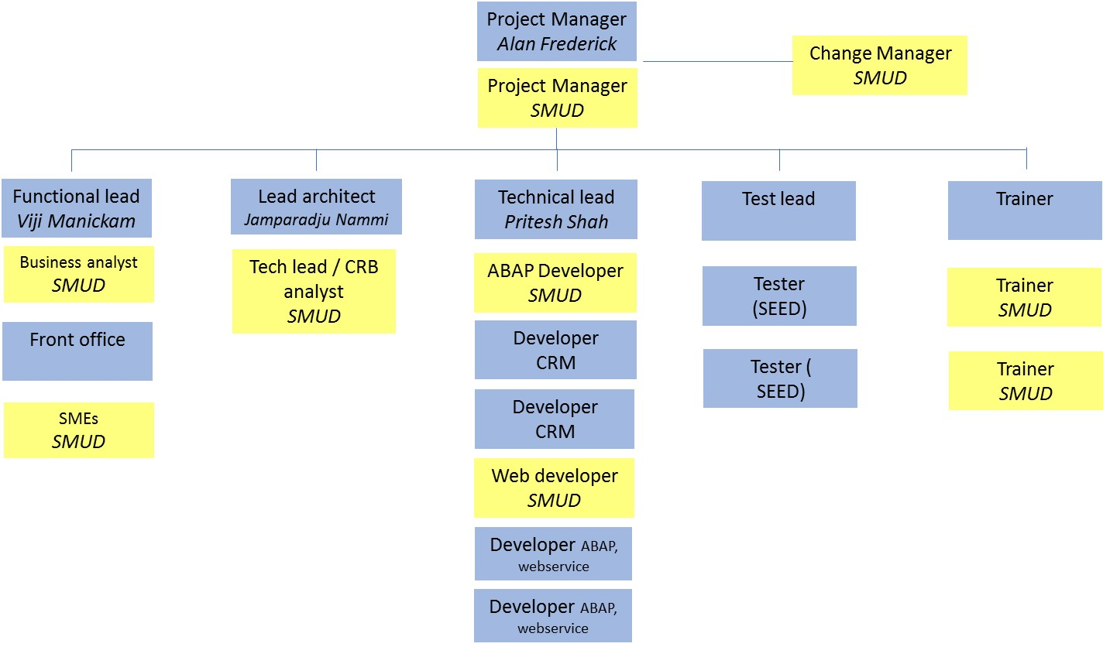
Figure 4: Project Organization chart

- Please provide a resume of key individuals on the proposed organization chart. The resumes shall include as a minimum the following information:
• Name
• Position
• Experience Summary (highlight information related to the scope of this Request for
Proposal)
• Educational Background
• Define Certifications
Please cross-reference the team members in their role in this project.
Response:
Please refer to Appendix 2 – Resumes section for the detailed Resumes embedded in the table below
Resource Name | Proposed Role | Resume
- Alan S Frederick | Project Manager
- Viji Manickam | Functional Lead
- Jamparaju Nammi | Lead architect (billing/DM)
- Pritesh Shah | Technical lead

- Please describe the 3 full cycle implementations or upgrades for each core team member who will comprise the Rate Change Automation project team, as noted under item #2 in the Mandatory Requirements section 6.8.1 above.
Response:
HCL proposes to staff the Rate Change Automation project with an experienced and familiar team of consultants. The following consultants have been identified as excellently suited for the key roles in the project. Additional project experience and SAP expertise for each consultant is included in their resumes.

Project Manager:

Alan Frederick
Directed and implemented the ‘Barcelona Project’, a $35 million project, which replaced the existing mainframe based CIS, Service Order Management, and Transportation Billing (settlement) systems, which were installed in 1990 with SAP. The solution included the following: CIS System, Transportation Billing, Mobile Work Management, Data Access and Reporting, and FRICEW. This project had a combined team of over 150 onshore and offshore team members. This large energy supplier in the North East is an integrated energy company distributed among four operating segments: Utility, Pipeline and Storage, Exploration and Production, and Energy Marketing. The Utility sells and transports natural gas to 750,000 Gas Customers spanning territories in Western New York and Pennsylvania. 650,000 residential customers, 52,000 commercial/industrial customers.
Led team of 27 onsite and offshore technical and functional resources for a hardware upgrade/migration and an SAP technical upgrade of ECC, CRM, and BW, modules to ECC 6 for an electric energy supplier in the West. Spearheaded a UCES upgrade and enhancement initiative. Collaborated with the client’s project manager, chief information officer, senior manager for infrastructure, customer service, and the PMO members to report progress and resolve issues.
Directed the implementation of the SAP ISU solution for CRM, IC Web, and Billing for Utility to establish central source of up-to-date customer information to provide advanced billing, customer service and infrastructure management capabilities. The large energy supplier in the West and its’s subsidiaries provide electricity and services to 95 percent of the state's 1.4 million residents.

Functional lead:

Viji Manickam
Currently Project Manager/Solution Architect at a utility company in the Pacific Northwest for a customer web portal technical upgrade to responsive web design: Design and solution implementation of MyAccount customer web portal through sprint delivery and agile methodology using SAP Web Application server Netweaver 7.2 and SAP CRB ECC6.0 Enhp 5
Post Go-live Solution Architect and BRF+ lead at a gas utility company serving 750,000 customers in NY and PA: Business rules design and configuration and solution implementation of complex processes with integration to external vendors, internal systems and meeting PUC regulations.
Solution Architect, overseeing design and solution implementation of pilot projects at electric utility on Hawaii: Time of Use(TOU), Net Metering, Solar billing, Revenue Adjustments and Fixed invoice Date.

Lead architect (billing/DM):

Jamparaju Nammi
Worked on an AMR implementation at a major electric and gas utility company in Michigan.
Deliveries included: Integration between SAP and RouteSmart for truck optimization, redesigning meter read validation process to accommodate change from manual reads to AMR reads, rate and profile change automation process.
Worked for electric and gas utility company in the north east as AMI solution consultant. The project integrated SAP with MDUS with the following service: meter reading services, remote disconnection and reconnection services, meter provisioning and deployment, billing services. An enrollment center was created for customer enrollment to different programs. Additionally, complex billing and a prepay solution were implemented.

Technical lead:

Pritesh Shah
Technical architect on the ISU CR&B (Customer Relation & Billing) implementation at one of the largest utility suppliers in the North East. It was a major project replacing their customer insight, billing and other legacy systems. The solution involved implementation of ECC, CRM, BW, BOBJ, PI, MWM (Syclo), Click and Stream Serve systems. Pritesh was responsible for system sizing, installation and landscape management including technical delivery of the FRICEW objects (Forms, Reports, Interfaces, Conversions, Enhancements and Workflows). Managed a team of 40+ onshore and offshore team members.
Led a team of 30 onsite and offshore technical resources for a major SAP roll out project for a global telecommunications company. SAP was rolled out to various Operating Companies throughout Europe and Africa, between 2009 and 2013. This project also involved upgrade of SAP HR module to Ehp6.0. Pritesh have worked closely with the client’s project manager, infrastructure team and various third parties. Multi-vendor environment.
Worked as technical lead for a SAP implementation at one of the biggest utility companies in the UK. The project was to replace the client’s backend legacy systems with SAP core modules (FI, HR, MM, SD). Pritesh managed a team of onsite and offshore technical resources for delivering FRICEW.

- This project will span multiple months. The Proposer must ensure in writing, that to the extent within its control, the personnel proposed to work on this project shall remain available to the project for the full term of the contract. Please also describe how you propose to ensure your core team member continuity?
Response:
The project plan is designed in such a way that consultants are allocated to the project on a full-time basis and continuously throughout the assignment. This ensures the team we assign remains on the entire project from the initial engagement through project completion. . HCL feels this practice ensures continuity, which benefits both SMUD and HCL.

- Please describe the skill set, number of staff (FTE) for both IT and Process Resource skill sets, and approximate amount of hours of SMUD staff needed for the project.
Response:
HCL utilizes a collaborative approach, where SMUD, HCL and other vendors work together as one cohesive team. This ensures rapid decision making within the team, process transparency and continuous knowledge transfer.
HCL believes that SMUD’s proposed project team, as outlined in the RFP, section 2.6A, accurately reflect the needed roles.
The estimated SMUD project team requirements are listed below. Please refer to the resource plan in section 6.8.3 T for the duration of each role.
- Project Manager: .75 FTE
- Technical lead / SAP CRB analyst: 1 FTE for both roles. This may well be 2 people.
- SAP ABAP developer: .5 FTE
- Business analyst: .75 FTE
- Web developer: .5 FTE.
- Change management specialist: .4 FTE
- SAP trainers: Suggested 2 resources with a combined allocation of 1 FTE on average throughout the project. Please note that the resource allocation will increase over time; expected resource requirement during design and build is .2 FTEs. During test and training 2 FTEs.
- Billing systems and operations SMEs: Combined effort 1 FTE. It is expected that this effort can be divided among multiple resources.

- Provide the name(s) of each organization with which you will be partnering and the purpose of the partnership. Describe the history of the partnership, current clients supported through this partnership, and services provided by each partner.
Response:
HCL has identified a SEED partner for the Rate Change Automation project: TechNet. Based on previous project experience at SMUD, HCL feels confident we can deliver SMUD’s business objectives and project requirements on time and on budget with TechNet. HCL partnered successfully with TechNet at SMUD for the SAP CRM for Utilities 7.0 project in 2011 – 2012. During this project, TechNet provided HCL with developers for the project. The overall engagement and partnership resulted in our teams working with SMUD to collaboratively lay the foundation for the SmartSacramento initiatives. HCL and TechNet have established a mutual agreement to extend our successful partnership for this project. TechNet will be responsible for some development and the overall test execution. By dividing the effort for HCL to primarily design and build the solution and TechNet test the solution, we will ensure the solution is examined through a “fresh set of eyes” to avoid a situation where the designers also test the solution.

- Detail out your approach, staffing and staff availability during preparation for go-live and after go-live.
Response:
HCL proposes a go live approach where the dialog and web functions are implemented at the same time. A go live readiness checklist is established during the project. This document is developed jointly between HCL and SMUD. It documents all activities that need to be completed in order to go live; system build completed, testing completed (see section 6.8.1 for more details), training completed, knowledge transfer completed, go live support staff secured, customer communication ready to be executed, etc., as well as other points mentioned in RFP section 2.8.4.5.
The initial runs of the mass rate change functions will be planned allow for a ‘soft start’, where the volume of data is smaller.
Immediately after go live there will be a hyper care period. It is recognized that customer requests for rate changes, particularly via the web channel, will occur outside of regular business hours. As such, a hyper care schedule will be established to ensure sufficient support staffing after go live. Triaging of defects is done daily and are defect resolution is executed based on priority, as defined by the defect severity. Defects are monitoring daily and adjustments to resourcing is done to ensure no backlog of defects is built up.

Experience
- Please provide a description of the Proposer's expertise in the area(s) as described in the Scope of Services of this Request for Proposal, including but not limited to workflow management, and automating rates & billing processes within SAP and CRM. Specifically address the three projects that meet Mandatory Pass/Fail Requirement No. 1 (Section 6.8.1)
Response:
HCL’s SAP – Utilities practice has proven expertise in best practices around the development and utilization of SAP solutions for utilities. With practical and in-depth experience working with utilities, HCL has delivered multiple transformational projects for utilities to improve business processes through the utilization of SAP. Based on our project success rate and our collaboration with SAP, o our team has extensive knowledge and project engagement experience with North American utilities. Our proposed team leads for SMUD have a deep understanding of people, roles, process, technology and how to manage operational and system challenges with change management. Functionally, our capability covers all areas of the SAP Utilities solution. Of particular value for this project is HCL’s expertise and experience in the areas of device management, EDM, AMI services, billing, contract management, BRF+ and BPEM (exceptions management). These are the areas that are primarily impacted by the solution HCL proposes.
Additionally, HCL has identified seasoned consultants with experience in working with workflows in a utilities-specific setting.
HCL has SAP full-cycle implementation experience and extensive experience with SAP billing and complex customizations, which is directly relevant to SMUD’s scope of work. HCL has provided a selection of utility project examples below. These clients are also available to review their experiences with SMUD.
Select Utility SAP CRB Implementation Experience
Company Name |  | Size | Services
 | Consumers Energy | 1.8M | Goal: Optimizing load management and operational efficiencies, achieving enhanced customer experience and increased customer satisfaction through CE’s smart energy journey.  HCL has partnered with CE on this journey and have worked on solutions such as complex billing, pre-pay, demand response, MDMR and MDUS integration. HCL is also providing all apps management for CE’s CRB (Customer Relationship & Billing) solution.
 | Washington Gas Light | 1.2M | Washington Gas implemented SAP Utilities on HANA for the deregulated markets in Maryland, Virginia, and the District of Columbia. Replacement of mainframe legacy system and more recent Open C system as well as integration to other existing legacy applications, some of which will be replaced later on.
 | National Fuel Gas | 720k | National Fuel Gas implemented SAP Utilities for the deregulated markets in New York and Pennsylvania. Replacement of mainframe legacy system as well as integration to existing mainframe applications that will be replaced later on. Field work and reporting solution was included in the project scope.

- Describe one implementation of a rate based solution where customers were billed from MDUS enabled meters. Describe the process of enrolling the customer on a rate.
Response:
The following rate automation implementation was done recently at Consumer’s Energy:
The user works from the ‘Enrollment center/Cutover to Interval Billing ’:
- A screen displays the different programs/products available.
- When the CSR click on the product, the system will provide the customer eligibility; whether the customer is eligible for that product or not. The BRF+ functionality is leveraged for eligibility determination.
- If the customer is not eligible, the system will provide the reason, which the CSR can communicate to the customer.
- If the customer is eligible, a popup describes the Product details and customer confirmation verbiage.
- If the customer accepts the terms and conditions, the CSR submits the product change, which will change the rate category. An Interaction Record is automatically created as well as an alert that the contract is TOD Pending.
- An event triggers the start of a workflow. The workflow updates the following data as applicable:
- Rate Category,
- Register Group,
- Perform automatic profile allocation
- Sends and Synchronize the Profile and register details to MDUS using the SAP standard AMI services
- Update the TOD Status as Enrolled in CRM
The solution as outlined above contained the following development objects:

SAP IS-U/ECC:
- BRF+: Enrollment eligibility rules
- Workflow:
- Change the Rate Category on Installation based on the billing cycle
- Change/Update the Register Group based on the product
- Automatic Creation and allocation of Profile if required
- Exception handling

SAP CRM:
- New Work Center for enrollment
- Interaction record for enrollment
- Enrollment alert on status bar.

Web:
- Customer Portal: Enrollment Center

- Please provide a description of the Proposer’s previous experience related to rate automation and workflow processes supporting billing changes as described in the Scope of Services of this Request for Proposal.
Response:
As indicated in sections 6.8.3 K and 6.8.3 L, HCL has extensive experience in implementing billing processes with integration to MDUS and MDMR systems, as well as extensive knowledge and experience of SAP and utilities processes in general and in the field of rate automation in particular.

- Describe how you will help SMUD meet its goals for operational efficiency, business process improvements and elimination of manual workflow processes when implementing these set of requirements in the following areas.
- Contact Center first call resolution for rate changes and moves/transfers
- Billing rate change workflows and exception management
- Web-based interfaces for rate changes and PEVs
- PEV tracking, edit/updating, and linking to SAP billing for discounted pricing on Time-of-day rates
- Reporting including batch and ad-hoc reports, notifications, alerts, dashboards, and workflow assignment/completion of tasks
- Data governance
- Other
Response:
HCL’s proposed solution is designed to maximize benefits while keeping to SAP standard functionality whenever possible. In the design phase we will work together with SMUD to confirm the requirements and confirm the design that will meet those requirements. Ensuring an understanding of the solution on SMUD’s part prior to building it is a very important component of the design phase. It is ensured via the deliverable review and sign off process. HCL’s extensive system and utilities experience puts us in a position where we can propose solutions where operational automation and efficiencies are balanced against complexity of implementation and cost of maintenance.
- Contact center first call resolution for rate changes and moves/transfers: The solution is designed to work in dialog mode, so that the CSR performs the rate eligibility check as part of a move/transfer request or rate change request. The CSR will inform the customer what options are open available to him.
- Billing rate change workflows and exception management: Leveraging BPEM cases as carrier for the rate change request means we use SAP standard objects as a foundation for a robust solution.
- Web-based interfaces for rate changes and PEVs: HCL has extensive experience in integrating with clients’ customer self service solutions. The interfaces will be designed such that standard SAP functions are called. This ensures adherence to standard, as well as ensuring that the functions are executed the same way whether it is from ICweb or the web.
- PEV tracking, edit/updating, and linking to SAP billing for discounted pricing on TOD rates: PEV information will be stored either as a BP attribute (ID type) or in a custom table, to be confirmed in design (see section 6.8.4). PEV data is updated either manually (by CSR based on customer information) or automatically (via interface with web). Billing relevant PEV information (installation facts) are updated automatically based on the PEV data on the BP. This is done via function implemented by the project and ensures that duplicate updates, and possible divergence of data, are avoided.
- Reporting: Leveraging the BPEM case as object means ease in tracking of progress of workflow process. Contract changes can also be leveraged to report on the number of actual successful changes.
- Data governance: Only trained and authorized users will have access to view and update data. This is accomplished through SAP’s security objects and composite roles. SAP’s standard validations ensure that rate data is consistent. For PEV data, logical checks will be implemented if applicable (e.g. duplicate VINs not allowed).

- Please identify the existing business processes and workflows that you expect will be impacted by the implementation of rate change automation, and describe your approach to identify and update those processes and workflows that will need to be updated.
Response:
The following system processes are expected to be impacted:
- Business Agreement (Contract Account) maintenance:
- PEV information will be stored linked to the Account object.
- Processes for validation of data are expected to impact the customer data update process. E.g. verification that there are no duplicate VIN numbers.
- Contract management:
- Contract start: Rate selection as part of the move in process.
- Contract change: Rate change request by the customer for an existing contract
- Contract end: Ending EV discount indicators as part of the move out process (but propagated forward if it is a transfer).
- Billing: The billing and invoicing processes are naturally impacted as customers switch from current rates to TOD rates. However, no changes to the process or the rate configuration are expected, with the possible exception of EV discounts (to be confirmed in design). Changes to validations (outsort check groups) or the processes for managing billing exceptions are not expected.
- Update technical master data: Updates to the installation object (rate category and installation facts) are expected as part of the automated rate change. Updates to meters and/or register groups are not expected.
- Exception management: A new BPEM case category and minor enhancements to the BPEM object are required.
- Correspondence: A new automatic process for triggering an EV discount letter will be required.
- Batch: New batch jobs built to support the automated rate change process must be added to the batch process.
- Web integration (web service): Rate change integration with the customer self service portal.
From a manual business process standpoint, these processes are impacted:
- Customer contact: The CSR will invoke the rate eligibility functionality as part of a move in and a rate change request. The process will entail explaining to the customer what his options are based on the returned results from the eligibility check.
- Customer contact: Update PEV information.
The areas above are identified based on SMUD’s RFP documentation, as well as HCL’s previous experience of rate automation projects. These will be confirmed during the design phase of the project.

- Provide an example of an approved detailed design document on an SAP Implementation performed.
Response:
Please find below the screenshots of one of the approved design document on SAP Implementation
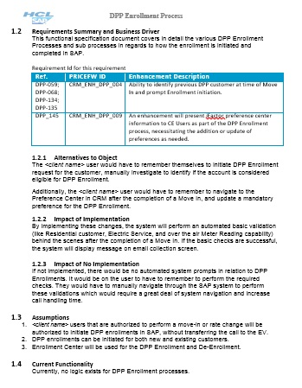
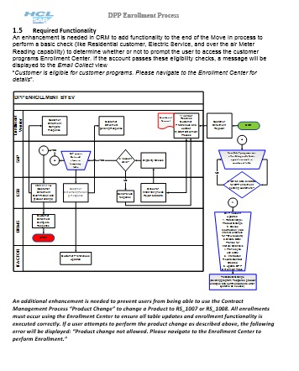
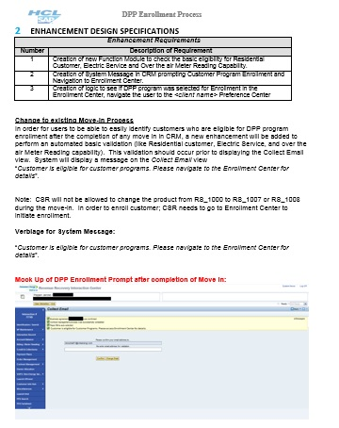
Figure 5: Screenshots of approved design document

- Describe your experience (implementation approach, collaboration experience with other clients, what was accomplished, and lessons learned) of SAP implementation specific to the electric utility sector.
Response:
HCL has extensive implementation experience in the utilities industry, and the methodology used in our implementation projects has been continually revised to incorporate lessons learned.
The electric utility sector has undergone some major technology enabled fundamental changes over the past few years. Communicating meters, integrated MDMR and MDUS systems have paved the way for new customer offers, leading to greater customer control over their electricity costs by managing their consumption pattern. This is not least evidenced by this RFP.
From a project standpoint, it is our experience and firm belief, that successful projects come from successful collaboration between SI and client. The ‘One Team’ approach, where all team members work together, bringing their particular skills and an open mind to the table, is key to a successful outcome.
Many of the processes in a utility company are largely automated and highly integrated, so a business process mindset, as opposed to a siloed functional mindset, is crucial.
In the project work, empowerment of the team members to make decisions is critical.
Transparency in the risk and issues resolution processes are important. It is each team member’s responsibility to raise any risks and issues promptly. It is the responsibility of the project management to clear road blocks by managing these risks and roadblocks in a timely manner.
Project decisions must be documented. Any project typically involve multiple decisions involving multiple people, often made over the course of several months. It is important to be able to go back and review the rationale for decisions at a later stage.
Sufficient testing of a solution is critical to a successful go live. In the context of this work, HCL specifically wants to stress the importance of thorough and exhaustive regression testing.

Project Methodology
- Please include a narrative description of how the Proposer will organize and perform the services as described in the Scope of Work of this Request for Proposal.
Response:
HCL has a proven framework and methodology for the management of projects through our Integrated Global Delivery Model (iGDM). It offers the best methodologies, templates, tools and a project management framework in the organization in a structured way.
iGDM is supported by a comprehensive project management toolset called APSE (HCL Project Support Environment). APSE has been specifically designed to manage SAP implementations providing a common repository for the management of design artifacts, deliverables, risks, issues, status reports, design decisions, project reporting, etc.

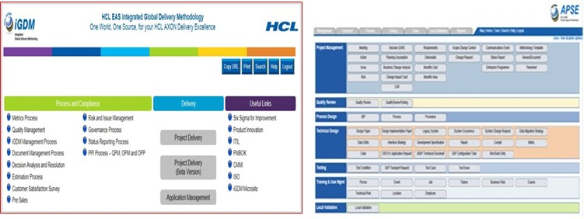
Figure 6: iGDM and APSE screenshot
iGDM is an extended SAP implementation methodology that is based on SAP’s Accelerated SAP implementation methodology (also referred to as “ASAP”) and is fully SAP ASAP certified. It is fully compliant with ISO and CMMI and observes PMBOK and ITIL principles. iGDM goes beyond the design, build and maintenance of the system, and focuses on the delivery of a sustainable and continuously improving business solution.
The following graphic shows how HCL’s iGDM methodology maps to SAP and PMI’s PMBOK methodologies:
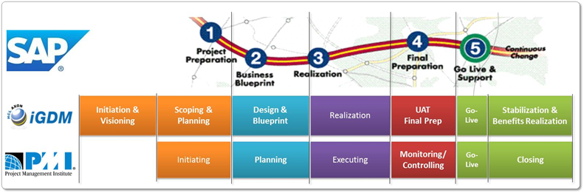
Figure 7: Aligning iGDM to SAP and PMI Methodologies
The key phases in a HCL-delivered project using the iGDM methodology and project roadmap are:
Initiation & Visioning – Understand Business Case, Identify Barriers, Develop Contract, Gain Leadership Buy In
Scoping & Planning – Planning for Blueprinting, Identify Best Practice, Mobilize Project team’s & Tools, High Level Design, Project Methodology Overview, Initial Benefits Identification
Design & Blueprint – Conduct Workshops to develop detailed design by process and business requirements, Create Phase Quality Plan (PQP). For realization, create Functional Specifications
Realization – Convert Design into Build, Unit Test, Integration Test based on newly defined org structure, Prep data for transition, conduct organizational readiness assessment
Final Prep & Go Live – Create & manage cut over plan, Go/No Go Decision, Evaluate metrics from FRICEW, trial cutover etc. Technical Readiness assessment
Stabilization – Stabilize the solution and optimize its performance, ensure full adoption of the solution by the Business, Conduct Post implementation review, handover to BAU team, handover to Application Support team
A strength of iGDM is its scalability. We tailor the project plan to suit the needs of this project, thus ensuring that we do not create unnecessary project management overhead. Section 6.8.3 T details the proposed project plan.

- Please describe how you will work with SMUD to ensure that the engagement of contracted resources will be managed to deliver optimum performance without compromising:
a. Quality of work
b. Communication
c. Knowledge transfer
d. Security
e. Development standards
f. Coding practices
g. Documentation styles.
Response:
HCL will engage TechNet to assist with the testing effort. Through active project planning, which is done together with SMUD, and monitoring of progress, optimum performance is expected.
- Quality of work: Review of delivered work and any adjustments resulting thereof is done continuously.
- Communication: Contracted resources will be part of the project team and included in all project communication relevant to them.
- Knowledge transfer: If necessary, knowledge transfer plans are created after assessment of the resources’ skills.
- Security: Contracted resources will be provided with access to test environments. Contracted resources are not expected to have access to production systems.
- Development standards: N/A. Contracted resources will be testing, not developing.
- N/A. See above.
- Documentation styles: All team members, contracted resources included, will be provided guidance regarding documentation standards. All documentation is reviewed for both content and format.

- Provide a detailed project schedule and align the schedule with the personnel resources that will be needed (yours and SMUD), and the assumptions you used to arrive at this schedule. Identify any risks associated with the schedule.
Response:
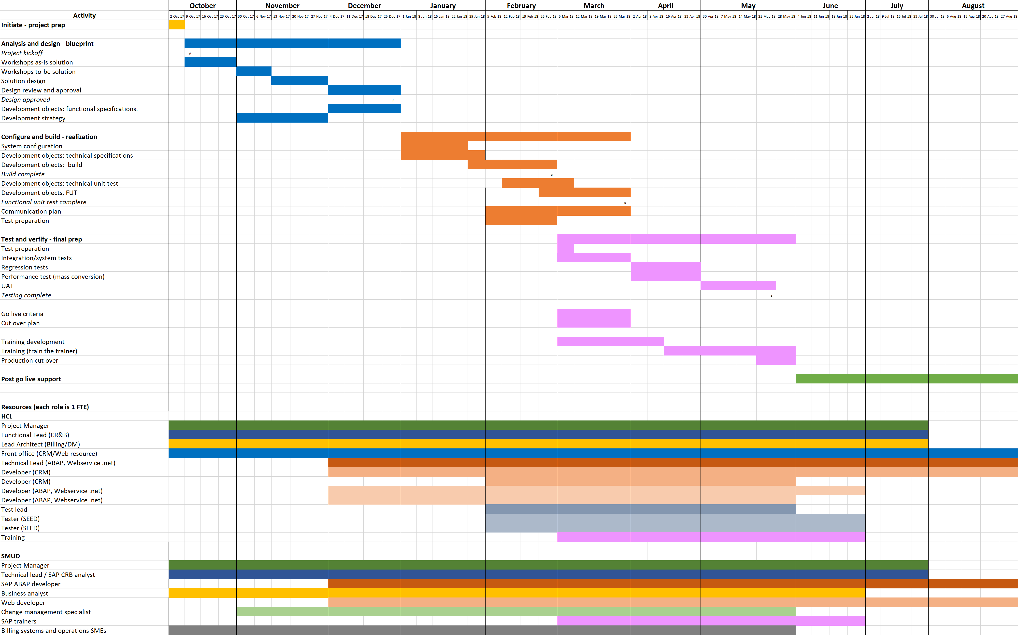
Figure 8: Project Plan

Assumptions
- Resources
SMUD will provide access to all systems, information and staff required to perform the defined services. Where these systems, information or staff are managed or held by 3rd Parties, SMUD will ensure that appropriate access rights are agreed with these 3rd parties.
SMUD will staff the project with the agreed number of personnel who have a strong understanding of SMUD’s existing operations.
SMUD will empower its project team members to make decisions, especially as they relate to process changes.
Consultants will work 40-hour work weeks, being on site on site Monday through Thursday. Both parties agree to work overtime when required to meet project timelines.
All staff is expected to take normal vacation and holidays throughout the course of the project except during stages of the project where their presence is critical. All vacation and holiday requests will be approved by the joint project managers.
Thanksgiving week is a remote work week.
- Facilities
SMUD will make available necessary facilities for Consultant personnel while on-site including:
- Office space and supplies
- External telephone line
- Email and internet access
- Administrative support as required (i.e., large volume copying or word processing)
- SMUD will ensure that Consultant staff has access to all relevant SMUD sites and 3rd party partner locations.
- Business Change
SMUD’s executive team is supportive of the implementation and will establish a steering committee for overseeing the project. This steering committee will provide visibility to management as to the status of the implementation and will include the following committee members: HCL’s Project Executive, HCL’s Project Manager, SMUD’s Project Manager, and other SMUD executives and key stakeholders, as appropriate.
SMUD’s executive team will provide appropriate executive level sponsorship and will participate in project related communications events as part of the overall project change strategy.
SMUD’s co-existing or planned initiatives may be a risk and a challenge to the project team. SMUD will be responsible for ensuring that the appropriate actions are taken to avoid any impact to the project schedule, staffing, and costs. HCL and SMUD will seek to resolve any potential impact as soon as it is recognized.
SMUD will ensure that middle management communities are appropriately engaged and committed to the project.
- Project Management
Prompt decision-making and problem resolution will be required to achieve an on-time, on-budget project completion. It is expected most decisions and/or problems will be resolved within a two-day time period. SMUD agrees to make every effort to make decisions within a two (2) day window. It is understood that all decisions may not be resolved in the two (2) day timeframe; however, SMUD agrees there is a one (1) week maximum timeframe. If the timeframe is not met the project schedule may be impacted.
Where decisions cannot be made by the defined program structures, SMUD will provide an effective escalation route, including a decision maker of last resort.
SMUD will review project deliverables and sign-off deliverables. A 3-day review turnaround period is expected.
SMUD will ensure that requests for additional functionality that are outside the agreed scope of the project are rejected unless agreed additional levels of additional resource are made available to the project.
SMUD will notify HCL of any change in circumstances that may lead to a change in requirements, scope or approach.
Project will utilize HCL’s APSE project documentation repository for the management of project deliverables and status as well as a Microsoft Project Plan (MPP). The MPP will only be updated if the overall schedule changes. HCL utilizes APSE for project status and control.
When appropriate, Consultant may work from Consultant’s offices or another suitable off-site location.
- Technical Assumptions
SMUD to procure all hardware and software required to implement the proposed solution.
SMUD will provide the servers and server infrastructure necessary to support the implementation in the timeframe called for in the project plan.
SMUD is responsible for providing all aspects of necessary technology infrastructure for both the project and production environments. This will include:
Host LAN and SAP access will be provided to all Consultants.
Fully functioning workstations, alternatively access via VMware or similar, will be provided at the start of the implementation for the Consultant’s use.
SMUD is responsible for ensuring that the network and operational infrastructure are appropriately configured, adequately sized, and functioning properly. These specifications will be designed to meet the performance, reliability, and service levels required to support the new configurations.
VPN tunnel to the Consultants office to allow the Consultant’s SAP systems to be visible from SMUD Project Site.
- Training and Change Management Assumptions
HCL AXON will provide the change methodology and templates for SMUD staff to oversee and perform the change deliverables.
SMUD has the facilities and will provide the necessary logistics support for all training sessions, including: class schedules, meeting rooms, training rooms, material reproduction, overhead projectors, training workstations, and any other necessary training supplies.
SMUD will ensure end-user attendance at training.

- Describe your project management approach for successfully implementing this project and accomplishing SMUD’s goal set forth in this RFP and business requirements.
Include information about:
  - Your project methodology
  - Why this methodology is a best fit for this project’s scope
  - Project preparation and planning activities
  - Budget management
  - Scoping and adherence to scope
  - Schedule development and adherence to the schedule
  - Risk and issue management
  - Resource management
  - Project Constraints
  - Control of the Work
  - Performance Standards
  - Responsiveness
  - Quality Standards
  - SMUD/Contractor Coordination
  - Administrative Requirements
Response:
- Our project methodology:
The methodology which will be used is iGDM, which is an extended SAP methodology, as described in section 6.8.3 R. This methodology has a proven track record in many projects; from very large CIS replacement and transformation projects, to limited scope implementations.
- Why this methodology is a best fit for this project’s scope:
It’s scalability, which allows us to leverage the strengths of the methodology without creating unnecessary management burden, makes this the best fit for this project’s scope.
- Project preparation and planning activities:
As this project has a well-defined scope and clearly defined requirements, much of the project preparation and planning has been done as part of this response. The project starts with a one week project prep phase (see section 6.8.3 T), where the plan and its assumptions are confirmed.
- Budget management:
To deliver the project, with quality, on time and on budget, is of the upmost importance. HCL’s governance model fully supports the budget management processes. The budget is managed by the project manager. Apse is used for tracking of progress of deliverables, leveraging the built in workflow functionality, which allows for instant access to current project status. In addition, weekly time reporting by HCL and SEED resources enables near real time tracking of planned vs actual resource usage.
- Scoping and adherence to scope
The scope of this project is defined by the content of the RFP and its associated detailed requirements. Our team will work closely with the SMUD Business and IT teams to document and validate our understanding of requirements and scope through a series of workshops during the blueprint design and validation phase. We will then validate that the proposed design will meet SMUD’s requirements. Additionally, the blueprint phase breaks down the requirements and maps them to the intended solution. Review and approval of deliverables, prior to commencing the build, confirms that requirements will be met by the proposed solution.
Adherence to scope is tracked against these deliverables. Any deviances from the scope are documented in Apse as ‘Scope Change Control’ documents, which are regularly monitored by leads and project management. All scope change controls must be either accepted or rejected. This approvals process is performed jointly with SMUD.
- Schedule development and adherence to schedule
The mid-level project schedule has been developed, see section 6.8.3 T. The schedule is broken down further during the project preparation phase.
During the project, the progress is continually tracked against the plan, and course corrections are made if necessary.
By leveraging the Apse and its workflow capabilities, project management is able to have a real-time view of actual progress vs planned progress.
In addition, each team member can see exactly what items are pending with him, and the expected completion dates in Apse.
Below is an example of the Apse workflow for a development object. The development lifecycle is represented by a number of workflow steps. Each step has a person assigned and a required date.
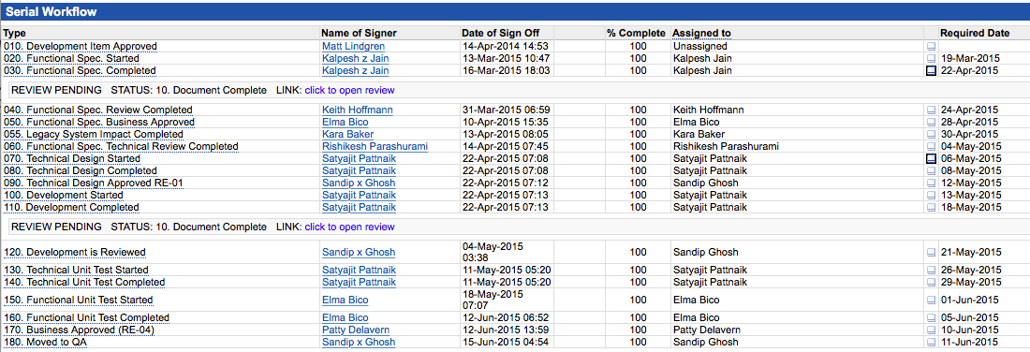
Figure 9: Example of APSE workflow for a development object
- Risk and issue management
The project tracks risks and issues as part of the RAID inventory (Risks, Actions, Issues, Decisions).
RAID items are documented and tracked centrally in Apse.
Leveraging the workflow in Apse means that issues are driven to resolution without the need to parallel email and tracking processes; Apse automatically notifies the next person in the workflow when the previous step is signed off. Apse also allows for easy status tracking of risks and issues.
See screen shots below for an example of an issue recorded in Apse.
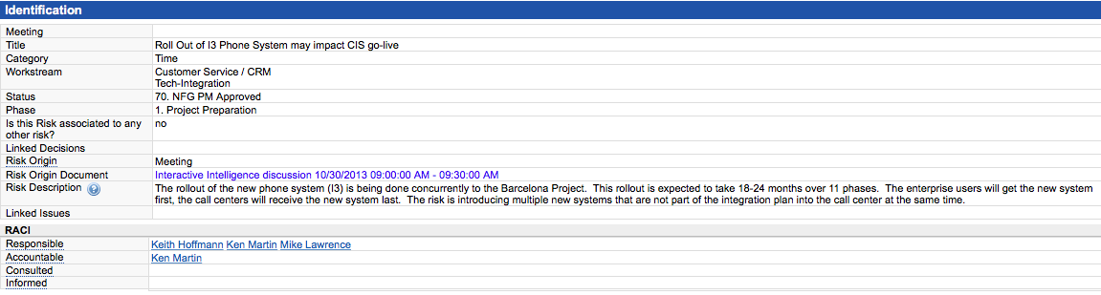
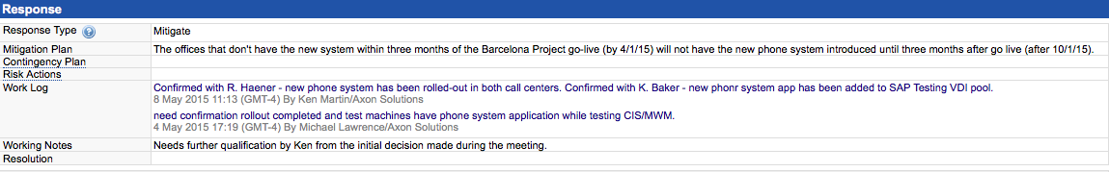
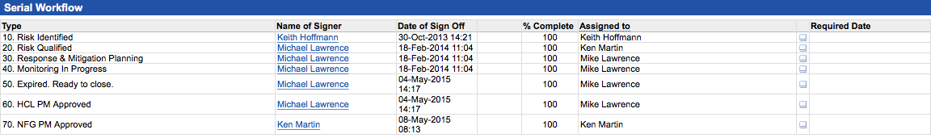
Figure 10: Screenshots for an example of issue recorded in APSE
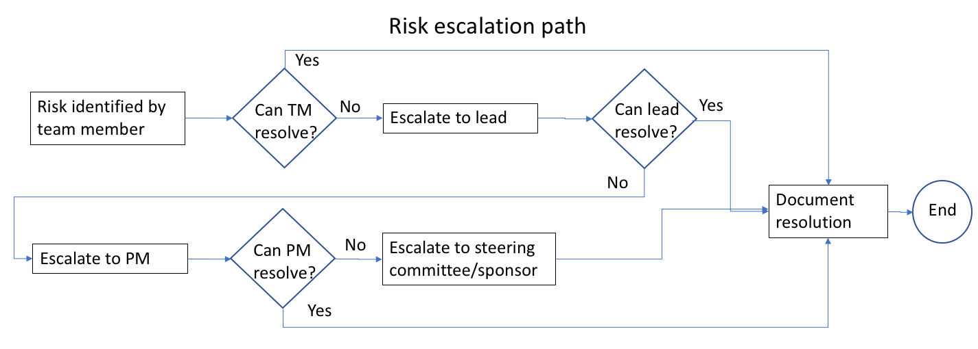
Figure 11: Risk escalation path
- Resource management
HCL and SEED resources are allocated to the project on a full-time basis for the duration of their roles’ engagements. This ensures complete dedication to the project and complete control over their time by the project management. As SMUD resources are allocated on a part time basis, SMUD and HCL’s project management must agree on which model to use for these resources. This is done on a resource by resource basis, as each role’s expected allocation differs.
- Project constraints
The project boundaries are set by budget, timeline, resource and technological constraints.
Our methodology ensures that project constraints are actively addressed via the project deliverables.
The RAID process (Risks, Actions, Issues, Decisions) enables early detection of constraints. Apse allows all team members visibility to constraints and activities initiated to address constraints, via project plans, RAID inventory and Scope Change Control documents, as well as design and test deliverables.
- Control of the work
Deliverables are reviewed and approved by SMUD and HCL, ensuring sufficient control of the deliverables.
Leveraging the workflows in Apse allows for tracking and control of progress of work, as discussed in 6.8.3 U f.
- Performance standards
The review and approval process allow, leveraging the workflow feature in Apse, allows for monitoring of planned vs actual performance. Any deviances are addressed immediately.
- Responsiveness
Weekly meetings with the project team allows for frequent and open two-way communication between the project management and the team, ensuring rapid responsiveness to issues needing addressed. Proactive work with the RAID inventory also facilitates rapid response to road blocks.
- Quality standards
Our quality management program, which is an integral part of HCL’s International Quality Standard ISO 9001:2000 accreditation, provides the framework for ensuring that quality objectives are set and both customer and regulatory requirements are met.
HCL’s senior management team is committed to ensuring that we achieve the highest levels of service delivery and customer satisfaction by continuously improving our people and processes and regularly reviewing the effectiveness of the quality management system.
- SMUD/contractor coordination
HCL firmly believes that a ‘one team’ approach is key to a successful outcome. As such, SMUD and contractor resources are managed by the project the same way as HCL resources.
- Administrative requirements
It is expected that SMUD’s resources are well versed in MSOffice products and that they use Apse during the project.

- Describe in detail your proposed change management strategy for this project. Include your thoughts on how change management compliments and/or interacts with other project activities.
Response:
Working proactively is one of the key components to a successful project. The change management strategy is developed by the HCL project manager together with SMUD’s change management resource, ensuring full integration with other activities. Train the trainer and end user training in particular, are important channels for change messages. The change management strategy encompasses:
- End users: How are the end users impacted? How will their daily tasks change?
- Customers: How are our customers impacted? How do we communicate new offerings?
- Leadership: How do we keep the leadership informed?

- Please provide your proposed schedule for the Rate Change Automation project that includes milestones, key deliverables, all resource requirements (including SMUD), and estimated timelines for the proposed SAP rate change automation and related workflow processes and reporting implementation at SMUD. Please document all assumptions made in developing the project plan. Include at a minimum:
- Project kickoff
- Sessions to develop detailed requirements
- Sessions to determine design
- Development of documentation (for example, but not limited to requirements, design, operational communication support plan, testing documentation, training documentation, security plan).
- Development and integration of solution
- Testing
- Training
- Launch
- Support
Response:

Figure 12: Project Plan
See mid-level breakdown of timeline and activities above.
- Project kickoff:
Scheduled for the first week of the blueprint phase.
The first week of the project is the project preparation phase, when deliverables such as project plan and resource plan are confirmed. The blueprint phase starts in week 2.
- Sessions to develop detailed requirements:
The blueprint phase is when detailed requirements are examined and the solution is designed.
- Sessions to determine design:
In the blueprint phase.
- Development of documentation:
Documentation is developed in the first four phases, although most of the documentation is developed in the blueprint and the realization phase. Design documentation is developed in the blueprint phase, together with functional specifications for the development objects. In the realization phase, technical specifications for the development objects are developed and technical as well as functional unit tests are documented. In addition, test scenarios and communication plan are developed during realization.
- Development and integration of solution:
The integration aspect of the solution is taken into account both during the design (blueprint phase) and build (realization phase). Confirmation that the delivered solution works as designed from an integrated perspective is achieved in the integration tests, which is a separate test activity in the final preparation phase.
- Testing:
Testing of the solution is done in the realization as well as the final prep phase. In realization the delivered solution is undergoing technical unit test and functional unit test. These tests are performed for each individual piece of functionality that is delivered. In the final prep phase, integration tests (system tests), regression tests, user acceptance tests and performance tests are performed.
All tests are documented: Test scenarios are defined, which include expected results. The actual test results are documented.
- Integration/system tests: Testing of integrated business process scenarios, including integration with external systems.
- Regression tests: Are performed to ensure that existing functionality and processes are not impacted by the new functions and processes.
- User acceptance tests (UAT): Acceptance tests performed by the business. UAT also includes security role testing. These tests are executed by SMUD resources that are not part of the project.
- Performance tests: Are performed on the mass conversion functions.
Defects: Any defects identified are logged and categorized. A defect is categorized as a deviation from the functional design in design documents and/or functional specifications.
- Training:
Training material is developed during the last month of realization and the first two weeks of final prep. The training schedule is also developed at this time. Train the trainer” courses are held during the last 6 weeks leading up to go live.
- Launch:
Go live criteria and a cutover plan are developed in the first month of final prep. A go live readiness checklist is established during the project. This document is developed jointly between HCL and SMUD. It documents all activities that need to be completed in order to go live; system build completed, testing completed, training completed, knowledge transfer completed, go live support staff secured, customer communication ready to be executed, etc., as well as other points mentioned in RFP section 2.8.4.5.
The cutover plan will list all activities associated with go live.
- Support:
HCL will support the solution for a period of 3 months after go live.

- Describe your proposed communication strategy for this project.
Response:
We believe that effective communication (written and oral) is a key driver to a successful project outcome. Our consultants are empowered to ensure communications are effective, concise, informative, timely, and targeted to the correct audience. We also believe that broader project communications should be handled centrally (i.e. via the Project Management Office) who would be responsible for managing/reviewing content before dissemination to the extended project team.
Communication is a critical element of program management. An effective communications and mobilization strategy is one, which has been well prepared, is timely, anticipates the results on the target audiences, and is owned by the business and sponsors within the business.
For the communications strategy to be effective, the following critical success factors should be taken into account in the development and delivery of all communication material:
- Communications must be tailored to meet individual stakeholder group needs and must be delivered using the appropriate media for that group
- The project vision must be easily understood by all audiences and communicate a motivating theme (change rationale) capable of being personalized by the receiver; i.e. ‘”What does it mean to me?”
- Communications must be based on clear and consistent messages at agreed times and provide easily accessible feedback channels to enable measurement of the communication’s effectiveness and impact
- Business sponsorship needs to be highly visible and reinforced regularly and there must be an effective monitoring mechanism.
In developing the communications strategy, a number of distinct activities are undertaken:
- Analysis of the key or target audiences within the business based on their different information requirements and project implementation status. This establishes a communication matrix on which communication interventions can be mapped
- Identification of a range of communications materials, media, delivery and feedback channels to meet specific stakeholder information needs taking into account information gathered in the Change Readiness Assessment
- Establishment of a series of key messages, based on agreed communications policies and protocols that remain consistent across the group and which are embodied in the communication materials
- Establishment of a communications monitoring regime to measure and fine-tune communications effectiveness
- The output of the communications strategy will be a communications plan.
- In this project, the communications strategy and communications plan will be developed and managed by the project managers. The strategy and plan are developed during the blueprint phase.
Both communication and status reporting provide good and effective sources of information. Moreover, effective, regular and timely status reporting provides an additional level of visibility to the overall program. Visibility is essential and we encourage our consultants to both consider a policy of continuous effective communication and regular status reporting throughout all work activities.

- Describe your issue tracking methodology and process for resolution and issue escalation.
Response:
The project tracks issue as part of the RAID inventory (Risks, Actions, Issues, Decisions).
RAID items are documented and tracked centrally in Apse.
Leveraging the workflow in Apse means that issues are driven to resolution without the need to parallel email and tracking processes; Apse automatically notifies the next person in the workflow when the previous step is signed off. Apse also allows for easy status tracking of issues.
See screen shots below for an example of an issue recorded in Apse.
Please note that these features are available in all object in Apse and will be leveraged for deliverables such as design documents, functional specifications and test cases.
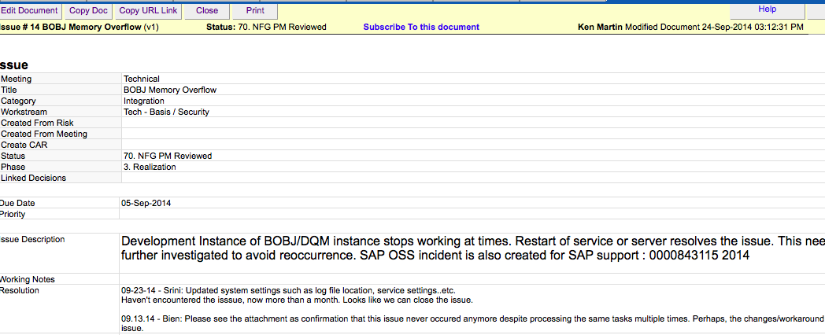
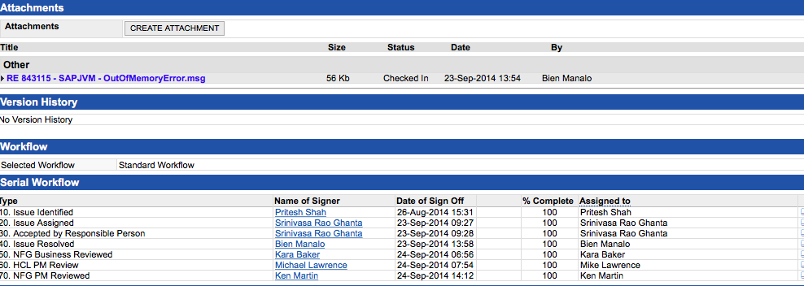
Figure 13: Screenshots for an example of issue recorded in APSE

The diagram below illustrates the escalation path for issues:
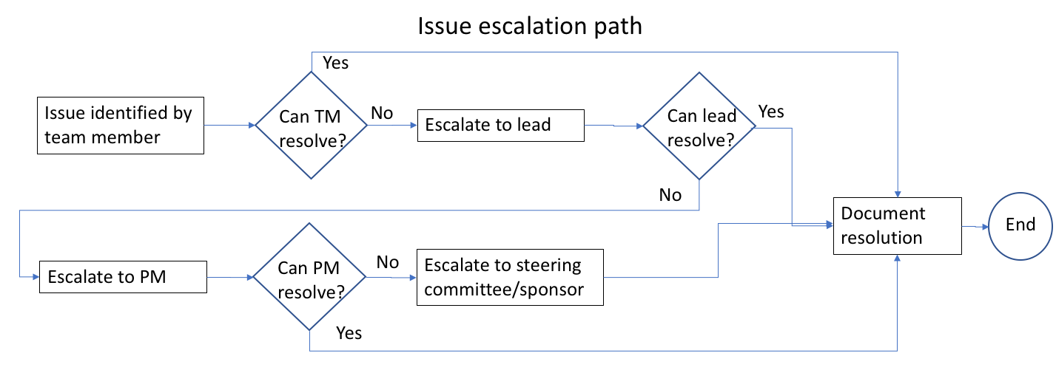
Figure 14: Risk escalation path

Evaluation Criteria 4 Functional & Technical Requirements - Core Features and Functionality
Proposer shall describe in detail the technical approach that will be used to perform the scope of work as described in this Request for Proposal.
Solution Architect, Customization, Integration and Performance

- Describe the standard features provided in SAP and note which features will be enabled to meet our stated project objectives within the project scope and requirements document.
Response:
The proposed approach leverages standard features as much as possible to meet the stated project objectives. Some enhancements will be required; this will be developed using the development workbench following SMUD ABAP development guidelines.
Standard features to be leveraged:
- CRM Contract Management and Alert Configuration
- BRF+ Rules Engine
- ECC BPEM Case
- ECC Rate Structure (Installation Facts)
- Development Workbench
The above functionality should already be activated in SMUD's existing landscape. No additional business function activation should be required.

- Describe the features that do not exist as standard SAP or CRM features and functionalities which will require customization(s) to meet our stated project objectives within the project scope and requirements document.
Response:
A number of enhancements is required to meet SMUD's project objectives.
- BRF+ setup to perform eligibility checks (assumption that some eligibility check criteria will require minor developments to perform lookups)
- Web service/function that can be triggered internally within SAP or from SMUD's web/IVR to:
- Perform rate change eligibility check
- Perform rate change (current or back-dated)
- Queue account for rate change (future-dated via BPEM case)
- Mass activities (parallel processing) to enable high volume customer eligibility check and rate change.
- Custom table and CRM views to support PEV repository.

- Describe your proposed solution on how to design, develop and incorporate a Rate Change repository into the rate selection and billing workflow processes, and also use for workflow management purposes.
Response:
Prior to designing the to-be process for automated rate change, the existing as-is rate change process needs to be reviewed and analyzed alongside with new business requirements. Some key information that is gathered include:
- Business rules required to determine customer eligibility (i.e. customer class, no rate change within last 12 months, etc.) and the actual rate change date.
- User base who will be performing this action (i.e. web, IVR, CSR, Back Office mass update (on-demand/scheduled)).
- Exception processing for failures via the specific trigger path.
Guiding principles used during the design/development of the processes:
- Leverage standard functionality where possible.
- Simplify business process by keeping storing data in logical places and maintaining business logic in one location.
- Minimize manual user intervention.

PROCESS OVERVIEW
Assumption: Business rule - Perform rate change as of next bill date plus 1 day
Individual Rate Change Request from Front Office User via CRM
- Access the Contract Management list view.
- Select relevant contract and click on the product eligibility button. This triggers for the specified contract triggers BRF+ to determine customer's eligibility for product changes.
- Results (i.e. customer's eligibility, PEV discount eligibility, eligibility start date, reason for ineligibility, etc.) from the BRF+ check is returned and displayed to the Front Office agent via the standard CRM message area.
- Upon confirmation from the customer to proceed with rate change, the agent creates a BPEM case of category Rate Change for the contract.
- The BPEM case is created with all key attributes stored as objects (i.e. source of rate change request, results of eligibility checks, etc.). Auto-processes are associated with the BPEM case category via configuration. The auto-processes (scheduled to execute periodically in the background) will, upon reaching the applicable rate change date, execute the CRM product change in same document function to migrate the customer to the new product (rate category) and associated attributes (installation facts). Any additional required functions (i.e. create a customer contact (replicated to CRM as interaction record) to denote a completed rate change) will also be performed. Performing a product change in same document will allow the customer to retain their ISU contract number.
- A new alert will be configured to check for open rate change BPEM cases so that it's clearly visible to the agent that a pending contract change is scheduled. This alert can be displayed at time of customer confirmation or navigation to the contract list view.
- If the customer changes their mind prior to the rate change being actioned, the BPEM case can be updated to cancelled and it will no longer be processed.

Individual Rate Change Request from Customer via Web/IVR (web service)
- Initiate Rate Change process via Web/ IVR. The Rate Change Eligibility check is executed via a web service.
- Results (i.e. customer's eligibility, PEV discount eligibility, eligibility start date, reason for ineligibility, etc.) from the BRF+ check is provided to the customer.
- Customer confirms that they would like to proceed with the rate change. A web service is triggered to create a BPEM case of category Rate Change (same case category as when triggered by CSR).
- The BPEM case is created with all key attributes stored as objects (i.e. source of rate change request, results of eligibility checks, etc.). Auto-processes are to be associated with the BPEM case category via configuration. The auto-process (scheduled to execute periodically in the background) will, upon reaching the applicable rate change date, execute the rate change function to migrate the customer to the new rate category and perform any other required functions (i.e. create customer contact (replicated to CRM as interaction record) that rate change has been processed, etc.)
- A web service can be made available to return an indicator of a pending rate change if an open BPEM case of type Rate Change is found.
- If the customer changes their mind prior to the rate change being actioned, a web service can be made available to set the BPEM case to cancelled and it will no longer be processed.

KEY ELEMENTS OF THE PROPOSED PROCESSES
- Evaluation logic is managed centrally within BRF+; capabilities to retrieve data from CRM and ECC for evaluation purposes.
- Pending rate changes from internal and external sources are managed within one specific BPEM case category.
- Enables simple reporting on the number of pending requests, the request source, status, etc.
- Auto processes is executed periodically; performs rate change action only when the eligible date has been reached.
- Easy cancellation of the rate change request in the event the customer changes their mind prior to the rate change effective date (no contract management implications)
- Easy identification from the front office and web/IVR that there is a pending rate change.
- Exceptions during the rate change process is captured within the BPEM case (i.e. failed auto-processing) and is easily identified for subsequent review.
- Rate changes executed immediately can be reported on using the CRM contract change data.

- Describe your proposed solution on how to design, develop and incorporate the PEV repository into the rate selection and billing processes, and track updates/changes to PEVs.
Response:
Based on the detailed requirements, the PEV information will be housed in custom Z tables: Vehicle Header and Vehicle Relationship. The Vehicle header table will contain vehicle specific information (i.e. VIN, make, etc.). This table will have a many to one relationship with the Vehicle Relationship table. The vehicle relationship table will contain the timesliced account information that correlates to the specific Vehicle. Change log functionality will be enabled on these Z tables for audit purposes. Custom views, with built-in checks, will be built to expose the data via CRM.
BRF+ is configured to perform eligibility checks for rate change. One of the BRF+ eligibility checks will be to lookup the PEV information (if any) stored to determine if the customer is applicable for additional discounts based on the rate selection. BRF+ can access data stored in CRM or ECC. If the customer is eligible for a PEV discount, this information will be retained and subsequently used by the Rate Change function.
To enable discounts to be applied at time of billing, a PEV discount eligibility installation fact needs to be set. This is a contract relevant installation fact that will automatically end-date when the customer moves out. Using the output from the eligibility check, this installation fact will be applied at time of rate change (product attribute to be maintained when executing product change in same document in CRM).

- Describe your proposal for the design and/or functionality of the PEV repository to support a future re-certification or verification process, which may include external interfaces.
Response:
PEV data stored within the Z tables can be updated via an interface or manually by a user. Upon creation/change of a PEV attribute (i.e. validity dates) a check should be executed against associated valid contracts to ensure that the product attributes (installation fact) for PEV discounts are aligned. Additional checks to ensure that the PEV is assigned to only one account at one point in time is to be included.

- Describe the proposed solution’s use of role based security and use of SAP security roles.
Response:
A number of user groups will have the ability to initiate a rate change.
Internal:
- Front office users via CRM
- Back office users via ECC to perform mass changes
External:
- Web
- IVR
Standard SAP security roles will be leveraged to enable users the ability to perform a rate change. New roles (individual/mass check/change) will be created and assigned to the applicable user/positions. Existing SMUD IDs used for web service transactions will be assigned the appropriate new roles.

- Describe your approach for the design and development of a mass rate selection and upload feature of existing customers transitioning customers from their current rate to a new rate. Be sure to explain how this can impact other utility business processes.
Response:
To support SMUD's mass rate selection and upload feature of existing customers transitioning to a new rate, we propose the below.
- A new mass rate change transaction (mass activity) with a parameter screen allows back office users to select installations (or other criteria) or upload a list of installations for rate change. An option is also provided to the user to initiate the rate change as of last bill date plus 1 day or next bill date plus 1 day.
Based on the selected installations and parameters, the system performs eligibility checks using the BRF+ logic for each installation.
- If the installation passes the eligibility check, the system creates a Rate Change BPEM case with associated attributes.
- If the installation does not pass the eligibility check, the system creates a Rate Change BPEM Exception case. These cases can be reviewed/reported on. Users are provided an option to ignore the eligibility checks and enable the rate change by manually adjusting the object parameters associated with the BPEM case.
- Solution processes can be executed against the Rate Change BPEM cases en-masse using the standard SAP transaction FPEMMAMA. * Note that if additional execution parameters are required, a minor enhancement is required to wrap transaction EMMACAP into a mass activity.
By leveraging the same Rate Change functions used by the front office agent via CRM and the Web/IVR web service, the exact same logic is executed. Any back-dated changes are immediately reflected. Future-dated changes are captured in a BPEM case for reporting and is visible to customers/front office agents.

- Discuss the top challenges you encountered in your past implementations of automated rate and billing workflow management solutions. Describe in detail how these challenges were resolved. Include how challenges were discovered, if resolution occurred before implementation or after implementation, the impacts these challenges had on the overall implementation, and the lessons learned.
Response:
Items for consideration when attempting to automate rate changes:
- Meter change (meter replacement/register group change) or billing install change (rate type)
A common scenario for a rate change is when a customer's load changes materially and is migrated from a small commercial rate to a large commercial rate. The tariff structure of large commercial rates typically requires a meter change as demand is a billing component. This requires the coordination of a service order to be completed prior to the rate change or a register group/billing install change (depending on the rate structure setup of the utility company). This challenge was identified prior to implementation and was addressed via business processes. Based on the MDUS initiative SMUD has described in the RTOD background section of the RFP, this challenge should be mitigated.
- Timing of change
Most utility have a business rule of not performing a rate category change mid-bill cycle (similar to SMUD). A business decision is generally made to determine whether a rate change should be initiated as of “last bill date plus 1 day” or “next bill date plus 1 day”.
On previous projects, the changes have been made as of last bill date plus 1 day. This approach worked well in general as any processing issues during processing are handled immediately. Issues with the customer data changing between current date and the next bill date which changes the eligibility is also eliminated. One comment from the business users post implementation was that from a customer communication standpoint, it would be a plus to notify the customer on the current invoice that the rate is changing as of the next invoice (#3 below).
To support a next bill date plus 1 day rate change, upon reaching the rate change date, eligibility checks should be re-executed to ensure the customer still passes the eligibility checks. (With a smart meter, a firm next billing date can be established with the assumption that no MRU change is made)
- Customer communication
This challenge ties into the timing of change above. Utilities generally provide customer with information when there is an upcoming rate/price change via generic envelope stuffers or messaging. If a rate change is performed as of last bill date plus 1 day, the opportunity to notify the customer prior to the actual rate change is lost unless a separate mailer/email is sent out to notify the customer of the change. This potentially creates a negative customer experience (i.e. they did not have a chance to adjust their usage behavior if they are switched automatically to a TOU rate).

- Based on the scope of work described in this RFP and business requirements, and your experience implementing similar projects, describe any challenges and/or risks you anticipate in implementing this project. Include risk mitigation steps you would take to minimize the risks.
Response:
Potential challenges with the rate change automation are:
- Eligibility changes while waiting for rate change date
- This can be mitigated by re-executing eligibility checks prior to the execution of the rate change (part of BPEM auto-process logic)
- Synchronization of PEV attributes at the BP level with product attributes/installation facts.
- This can be mitigated by performing additional checks on change of PEV attributes or contract change.

Reporting and Tracking
- Describe your proposed method of storing and leveraging rate change and PEV historic and active data in SAP for purposes of eligibility rules, reporting, audit trails and interfaces.
Response:
Data relevant to the rate change activity is maintained within SAP:
- PEV data will be maintained in Z tables: Vehicle header and Vehicle Relationship
- Actual rate change is captured within Product Change in Same Document transaction in CRM, the actioned BPEM case, and the installation timeslice in ECC.
- Pending rate change and rate change exceptions are captured within ECC BPEM cases.
Eligibility rules are maintained in BRF+ (capabilities to access data from both CRM and ECC)
Reporting can be supported by querying the data maintained at the various SAP storage location.
SAP standard change logs are enabled on the above data (providing a full audit trail)
Interfaces can perform updates to data in CRM/ECC.

- Describe your proposed solution on how to configure the workflow management reporting solution specific to this RFP and business requirements.
Response:
Data relevant for the rate change is maintained either in:
- ECC Z Tables (PEV details)
- CRM Product change in same document transactions (Successfully actioned rate changes)
- ECC BPEM Cases (Pending/failed rate changes)
Simple reports can be built in CRM to report on PEV details and product changes. BPEM case content is likely already exposed to the BI environment for reporting; else simple reports can be built in ECC to report on pending/failed rate changes.

- Describe your proposed solution on how to address the reporting needs specific to this RFP using standard or customized SAP solutions.
Response:
Data relevant for the rate change is maintained either in:
- ECC Z Tables (PEV details)
- CRM Product change in same document transactions (Successfully actioned rate changes)
- ECC BPEM Cases (Pending/failed rate changes)
Simple reports can be built in CRM to report on PEV details and product changes. BPEM case content is likely already exposed to the BI environment for reporting; else simple reports can be built in ECC to report on pending/failed rate changes.

- Describe how your solution will be designed to increase operational efficiencies and existing reporting and tracking capabilities, and provide accurate and consistent quality data within SAP and CRM.
Response:
Three key pieces of data will be reported upon:
- PEV details (ECC Z Tables)
- Successfully actioned rate changes (CRM Product Change in New Document)
- Pending/failed rate changes (ECC BPEM Cases)
Each type of data is logically stored once; there is no duplication of data which would cause inconsistency.
All data can also be easily queried.

- Describe how your proposed solution can increase process and data visibility and support SMUD’s Enterprise Data Governance Program.
Response:
The proposed solution aims to maximize the use of standard functionality and also the use of standard change history. During implementation, considerations in establishing controls (i.e. additional checks) around the management of data to keep it in sync (particularly for PEV attributes and the associated product attribute) would be prudent. Clearing defining roles and responsibility for maintenance of data is also required.

- Describe how your proposed solution will improve exception processing for billing and rate changes, including alerts and tracking for workflow management. Include how, if any, of the reporting or tracking will be managed within SAPs BPEM module.
Response:
All rate change requests will be managed within BPEM. Auto processes associated to the case will trigger the appropriate rate change action upon reaching the eligible rate change date. Outstanding items are clearly visible and individual cases can be assigned an owner if required.
Alerts will be configured in CRM to check for any new/open BPEM rate change cases so that front office users have visibility into pending changes.

Testing, Training and Support
- Describe your approach to on-the-job training of SMUD developer and functional staff during the project to understand the solution. Include the approach for updating and creating detailed training documents.
Response:
HCL strongly believes in engaging the customer team during all phases of the project. A collaborative approach to working together has proven to be an effective way to ensure a fundamental understanding of the design and the continuity of knowledge/support post go-live.
In all phases, relevant SMUD functional and technical resources will be included in workshops/meetings and informed of all fundamental decisions. SMUD resources will also be included in testing activities early (prior to integration/user acceptance test) so that any gaps/adjustments to processes/developments can be identified and addressed early. Functional and technical specifications produced by the HCL team will be reviewed with identified SMUD resources to ensure the design is understood.
The HCL functional resources will engage the SMUD training team upon completion of design to provide an early overview of the processes so that OCM considerations and high level training plans can be initiated. Upon completion of build and test, the HCL team will walk through the business processes within the system so that the training team has a good understanding of the upcoming changes and be able to confirm the required training document content.

- Describe in detail the roles of analysts, developers, and/or base team members in validating properly operating interfaces with the web, repositories and automated process flows in CRM and SAP. Describe the documentation and training that will be provided to IT staff and how it will address the process for any future updates made to the customized solution to ensure the processes remain whole and functional.
Response:
HCL functional and technical analysts are responsible for unit testing the configured/developed components. Prior to integration test with external systems, assembly test is performed to ensure the end-to-end processes within the SAP environment is behaving as expected (i.e. inbound web service may be simulated or an inbound interface file may be mocked up to test functionality)
Functional/Technical specifications and test scripts will be documented and reviewed with SMUD stuff to ensure that the solution is fully understood.

- Describe your Test metrics and defects tracking and resolution process.
Response:
HCL leverages the APSE tool to drive the testing process. Test items (linked to specific business processes/developments) are logged within APSE. Any defects raised from the test is linked for full visibility into the affected areas. Workflows built into APSE manages the assignment of defects for resolution.

- Describe your approach for the regression testing of existing custom objects in SAP and CRM, such as batch processes, workflows, etc..
Response:
Business areas that may potentially be affected by the rate change process (i.e. billing, CRM contract management) should be tested. With SMUD's input, a list of standard and custom processes should be identified for regression testing. Participation of SMUD's functional resources is necessary to ensure the regression tests are executed per SMUD's existing business processes.

- Describe your post go-live support strategy.
Response:
Functional and technical resources will remain engaged after the go-live to support any training/process related queries. In the event an issue is identified; the functional resources will triage and identify if it is a training/process issue or a defect. Depending on the outcome of the triage, appropriate action will be taken for resolution (i.e. training documentation update, configuration/development update)
HCL will work closely with SMUD resources over the transition period to ensure any business process/system changes are communicated.
HCL will also proactively monitor the system for any process anomalies related to the newly implemented functionality.

- Describe your training methodology and strategy. Describe how you plan to incorporate SMUD feedback in any training documentation.
Response:
HCL will engage SMUD's training team upon completion of the analyze and design phase. A high level scope of the affected areas is identified by that time and can assist the training team in defining the training activities required.
Feedback will be solicited on training documentation as they are being developed so that the end-result is as expected.

- Describe your testing methodology and strategy for all phases of testing (unit, integration, system, data integrity, regression, performance and UAT). Include your approach for development test strategies, test cases and test scripts for the multiple phases.
Response:
Each test phase aims to satisfy specific criteria.
Unit Test:
- Test detailed logic (i.e. combination of different flags/dates to drive eligibility rules)
- Permutation of business processes are successful
(i.e.
- customer passes eligibility check but does not perform rate change
- customer passes eligibility check and performs past dated rate change
- customer passes eligibility check and performs future dated rate change)
Integration/System Test:
- Test integration of various business processes together (including inbound/outbound communication with external systems)
- Primary objective of this phase is to confirm that expected inbound/outbound data exchanged with external systems align with expected values and that internal SAP process hand-offs are correctly performed.
Regression:
- Test that existing processes that have not been explicitly changed by the project continue to function as required.
Performance:
- Test that the desired volume processing can be handled.
UAT:
- Confirm that the business processes function as designed.
Test strategies are established collaboratively with the functional/technical/test lead. Based on the customer's landscape and type of data available for testing, the scope of the activities, a plan is created to facilitate the creation, management, and execution of the required test activities.
Test cases/scripts are identified in the analyze and design phase (BPD) and within functional specifications. This ensure that the system functions are tested to support the required business process.

- Discuss your expectations for use of the sandbox, development and QA environments.
Response:
Sandbox:
- Perform proof of concept configuration and development. Using this environment, HCL will prototype solutions to assist the team with final design decisions.
Development:
- Perform configuration and development. Unit testing occurs in this environment.
QA:
- Perform integration, performance, regression, end-to-end, and user acceptance testing.

Evaluation Criteria 5 Commercial Terms (Price) and Compliance with SMUD's Contractual Terms
- This section includes the cost information contained in the Bid Schedule section of this Request for Proposal.
- The Proposer shall note all exceptions taken to this Request for Proposal including the contract terms and conditions of the contract included in the Sample Contract section of this Request for Proposal. SMUD reserves the right to reject any proposal based on noncompliance with the attached contract terms and conditions.
Response:
HCL proposes to use the existing MSA between SMUD and Axon Solutions, Inc., Dated 19 April 2011.
A Table of Exceptions to the proposed SMUD Sample Contract is available for review in Appendix 3 – HCL Exceptions section.

BID SCHEDULE
RFP No. 170061.MP
In accordance with this Request for Proposal, the Proposer agrees to provide the services described in the Scope of Services, at the rates shown in this Schedule.
The quantities shown below are approximate only and being given as a basis for the comparison of proposals. SMUD does not, expressly, or by implication, propose or agree that the actual quantities of work will correspond therewith, but reserves the right to increase or decrease the amount of any portion of the work shown, or to omit portions of said work, as may be deemed advisable by SMUD. Payment will be made on the basis of quantities actually performed.
ITEM NO. | DESCRIPTION | QTY. | UNIT | TOTAL PRICE
1. | Implementation Services (Professional services including system implementation, CRM and SAP Back-end configuration, customization, repositories, reporting and data conversion) ¹  Includes all travel and expenses | 1 | Lump Sum | $1,886,000
2. | Technical and Functional End-User Training (Training includes a transfer of knowledge from the proposer/sub-contractor such that SMUD staff is able to completely manage and maintain the EELMS.) | 1 | Lump Sum | $708,000
3. | Two (2) months on-site post production support (per Section 2.8.6.8) | 1 | Lump Sum | $402,000
4. | One (1) month off-site post production support, responds within 2 hours Monday through Friday, 7 am to 4 pm PST | 1 | Lump Sum | $96,000
5. | Other cost required for proposed solution but not captured in item 1-4² | 1 | Lump Sum | $0
6. | TOTAL COST FOR LINES 1-5 |  |  | $3,092,000
Note: SMUD’s evaluations for award will include SEED Price Advantage calculations
¹Please provide a breakdown of costs included in Line Item 1.
Response:
Initiate/Plan and Design (30%): $565,800
Configure, Build, Unit Test (40%): $754,400
Test and Verify (30%): $565,800
Total: $1,886,000

* Note that the functional technical team performing the design/build/test activities are also performing training/knowledge transfer activities in the duration of the various phases. The corresponding amounts related to training/knowledge transfer are reflected in item no. 2.

²Please provide a breakdown/details (including any third parties or required licensing or software) below included in Line 5.
Response:
N/A = $0

OPTIONAL ITEMS (NOT USED IN THE COMMERCIAL EVALUATION)
Description | Unit | Price
Future Professional Services (Future professional services needed for system modifications, customizations, or SMUD training at any point during the contract term will be billed at this rate). Rate includes travel and expenses | Hourly Rate | $

In case of discrepancy between the words and numbers of the bid price, the words shall govern. In case of discrepancy between the unit prices bid and the extensions thereon, the unit prices shall govern. In case of an error in the addition of the total bid amount for all bid items the corrected total shall govern.
The rates proposed above shall remain fixed for the duration of the contract unless otherwise approved in writing by SMUD.
PROPOSER:
Company:
Street Address:
City: State: Zip:
Signed:
Print Name:
Title:
Telephone: Fax:
Email: Date:

Appendix

Appendix 1: Acknowledgement of Addendums

Acknowledgement of Addendum 1
<insert here>

Acknowledgement of Addendum 2
<insert here>

Appendix 2: Resumes
Please find below the detailed Resumes of the key individuals on the proposed organization chart
Resource Name | Proposed Role
- Alan S Frederick | Project Manager
- Viji Manickam | Functional Lead
- Jamparaju Nammi | Lead architect (billing/DM)
- Pritesh Shah | Technical lead

  - Resume of Alan S. Frederick (Project Manager)
SUMMARY
A senior consulting professional (IBM, Deloitte, CSC) with extensive experience in the architecture, solution development, planning, and implementation of cost-effective SAP installations that meet the evolving needs of businesses. Combines leadership roles in corporate environments with experience in management consulting firms. History of developing strong business relationships with and consultative selling to C-level executives. Positions held range from project manager, program manager to client partner and principal. Proven success in merging disparate operations, process reengineering/improvement, and developing teams into cohesive performance-driven units. Known for the ability to design and execute enterprise-wide strategic operational change initiatives in alignment with client business needs. Committed to continuous business improvement – a high-output, results-driven change agent.
SKILLS
SAP | - 21+ years SAP specific experience  - Managed 16 SAP full project lifecycle implementations ranging from $5 million to $83 million in size with teams ranging from 20 – 225 people. Projects were both national and global in scale. Modules included FI, CO, SD, MM, APO, HR, PP, QM, WM, AM, ICM, IPM, CRM, EHS, SRM and PS  - Discrete, lean, process & repetitive manufacturing experience in industrial manufacturing, automotive, aerospace, steel, chemicals, and hi-tech  - Strong process and industry knowledge in financial services, utilities, banking, insurance, manufacturing, consumer products, and publishing
SELECTED PROJECT EXPERIENCE
Company | HCL AXON (Irvine, CA)
Duration | 2009 – Present
Position | Program Director
Responsibilities
Program Director in the SAP Service Division responsible for the sales and delivery of SAP implementation projects. Responsibilities include developing channel and client relationships at the C-level, identifying and closing new business opportunities which utilize HCL AXON capabilities, and managing SAP vendor relationships. Delivery responsibilities include providing advice and counsel to clients, with oversight and direct accountability for the successful delivery of SAP implementations and client satisfaction. Manage and provide oversight for multiple SAP implementation projects.

Company | National Fuel Gas, Buffalo, New York
Responsibilities
Directed and implemented The Barcelona Project, a $35 million project, which replaced the existing mainframe based CIS, Service Order Management, and Transportation Billing (settlement) systems, which were installed in 1990 with SAP. The solution included the following: CIS System, Transportation Billing, Mobile Work Management, Data Access and Reporting, and FRICEW. This project had a combined team of over 150 onshore and offshore team members. National Fuel Gas Company is an integrated energy company distributed among four operating segments: Utility, Pipeline and Storage, Exploration and Production, and Energy Marketing. National Fuel Gas Distribution Corporation, the Utility, sells or transports natural gas to 750,000 Gas Customers spanning territories in Western New York and Pennsylvania (650K Residential, 52K Commercial/Industrial).

Company | Performance Food Group, Richmond, Virginia
Responsibilities
Created and directed the Program Management office for a $55 million program to upgrade SAP and rollout a new operational ERP for all PFG operating companies (11 companies totalling $13 Billion in size) across the United States and 40 foreign countries. The PMO led the rollout planning along with defining the schedule and resources required for the rollouts. We established project plan standards, risk and issue reporting, implemented project and program management methodology, and standardized status reporting.

Company | Hawaiian Electric Company (HECO) (Honolulu, Hawaii)
Responsibilities
Directed the implementation of the SAP ISU solution for CRM, IC Web, and Billing for Utility to establish central source of up-to-date customer information to provide advanced billing, customer service and infrastructure management capabilities. The Hawaiian Electric Company and its subsidiaries (Hawaiian Electric, Maui Electric, and Hawaii Electric Light) provide electricity and services to 95 percent of the state's 1.4 million residents.

Company | Tacoma Public Utilities
Responsibilities
Managed and directed the SAP iEM solution to provide enhanced online payment options and create a customer centric website experience. Team included client SMEs and consultants using Rapid Application Development methodology.

Company | Cisco Systems, Inc.
Responsibilities
Cisco Systems, Inc. designs, manufactures and sells Internet protocol (IP)-based networking and other products related to the communications and information technology (IT) industry and provide services associated with these products and their use. The Company’s product offerings fall into three categories: its core technologies, routing and switching; advanced technologies, and other products. In addition to its product offerings, the Company provides a range of service offerings, technical support services and advanced services. The advanced services program supports networking devices, applications, solutions, and complete infrastructures.
Cisco outsourced their ITPA (SAP IT Process Automation) product to HCL Axon. HCL is responsible for the software development, testing, pre-sale support, training, lab administration and sustenance of future releases of the SAP ITPA system, as well as sustenance of existing releases of the SAP ITPA system in accordance with the requirements and specifications provided by Cisco to HCL. Directed the transition of ITPA from Cisco to HCL Axon.

Company | ZEP
Responsibilities
ZEP – Zep is a specialty industrial chemical company whose focus has been to offer customers the widest selection of top-quality industrial chemicals. The company has operations in North America and services customers in a variety of industries including automotive, hospitality, food processing, car washing, government, manufacturing, institutional, and municipalities.
The ZEP Monarch Project was initiated to replace legacy systems with SAP ECC 6.0. I directed the implementation of Monarch which encompassed SAP SD, MM, IM, FICO, WM, QM, PP, BI, and EHS. I provided the program and project management necessary to implement SAP on time and budget. ZEP has 3 manufacturing facilities and 14 warehouse facilities located domestically and internationally.

Company | Wolters Kluwer (formerly CCH)
Responsibilities
Wolters Kluwer (formerly CCH) – WK is a multinational publisher and internet content provider with operations in over 80 countries. They desired to replace their multiple legacy systems with SAP. I developed a SAP one instance strategy for the multiyear International and Domestic roll out of SAP throughout Wolters four business divisions. Established a SAP template that became the foundation for the SAP implementations with localizations for business units and countries. This included FICO, MM, SD, ICM, IPM, CRM, and BI. Rationalized business practices across units, both domestic and international, and reengineered processes utilizing best practices where possible. Built credibility with the client and established HCL Axon as a trusted partner and strategic vendor. $52 million project

Company | Wolters Kluwer Financial Services
Responsibilities
WKFS – Replaced their current Peoplesoft Case management system with SAP’s CRM 7.0 solution. In addition, we implemented a common solution and platform across all business units so that they would benefit from possessing a holistic view of each customer’s experience from Sales, through Order Entry, to Support. The solution also provided partner reporting and well as a comprehensive customer self-service solution.

Company | IBM (Agoura Hills, CA)
Duration | 2007 – 2009
Position | Associate Partner
Responsibilities
Associate Partner in the Industrial Supply Chain Management SAP Practice. Assists clients in the selection, implementation, and support of SAP application packaged solutions. Used in-depth consulting skills, business knowledge, and packaged solution expertise to effectively integrate packaged technology into the clients’ business environment in order to achieve client expected business results. Manages multiple projects as well as identifying new SAP consulting opportunities. Develops strong relationships with client middle and executive management. Proven track record of implementing SAP 3.0 through ECC 6.0 & BI 7.1 with multiple full life cycle implementations.

Company | British Petroleum
Background
The Tulsa Exit Program was initiated by BP to mitigate the group risk that was identified with the hosting of business applications at their Tulsa Data Center. The Tulsa site hosts 36 SAP group systems which are critical to BP's business. The Tulsa facility has physical limitations because it is in a modified commercial building so it was decided to close the Tulsa Data Center and migrate all applications to other data centers in Chicago and London.
Responsibilities
My role as Engagement Executive was to create the architecture and migration strategy that would be used by the 3 year $83 million project to migrate the SAP systems to Chicago and London. This architecture included three different platforms Solaris/Sparc, Solaris / X86, and Wintel. I established a migration approach and schedule, project team structures for the individual projects, and testing approaches for all migration subprojects. I interfaced with BP personnel and outsourced vendors such as IBM, Accenture, and Wipro.

Company | Fireman’s Fund Insurance Company
Background
Fireman’s Fund's parent company, Allianz (AZL), AG, of Munich, Germany, is among the largest property and casualty insurers in the world. Allianz operates worldwide through more than 200 subsidiary companies and writes more than $53 billion in worldwide property/casualty and life insurance premiums.
FFIC implemented an SAP platform to support core financial processes and reporting for both FFIC and AZL. The work that was performed was part of the effort to standardize Allianz North American Operating Entities on the SAP Financials platform which will support core-finance requirements: COA, Accounting Close and Consolidation.
Responsibilities
The SAP implementation took place in both Novato, CA at FFIC and in Minneapolis, MN at Allianz North America. I led a team of 86 people (IBM and client) spread across both locations to implement mySAP 2005(v6.4) and BI 7.0. The modules implemented included FI, CO, BW, and EC-CS and a custom Allocations program. The implementation also included developing a data integration layer using Informatica. This fed data from existing systems (including Peoplesoft), through 59 interfaces, to SAP. RICEF objects included 175 reports, 59 interfaces, 9 conversions, and 34 enhancements. I held P & L responsibility for the $18 million dollar project.

Company | Ticketmaster LLC. (Los Angeles, CA)
Duration | 2003 – 2007
Position | Director – Financial Systems & Process Improvement
Background
Ticketmaster is the world's leading ticketing company, providing ticket sales and distribution through one of the largest e-commerce sites on the Internet; approximately 3,300 retail Ticket Center outlets; 19 worldwide telephone call centers; and a broad online and offline marketing network. Ticketmaster serves more than 9,000 clients worldwide across multiple event categories and sold 98 million tickets valued at $5 billion in 2004.
Responsibilities
- Directed the global implementation of SAP R/3 4.7 financials, purchasing, and ICM
- Led the reengineering effort of IT, operational, and financial processes with a target goal to reduce expenses by 30%
- Directed the accounting, financial reporting and internal control functions of the organization worldwide. Ensured Ticketmaster accounting and reporting was in compliance with US GAAP, SOX, as well as local statutory requirements

Company | Vought Aircraft Industries
Duration | 2001 – 2003
Position | Senior Vice President
Background
Vought Aircraft Industries manufactures aircraft wings and fuselages for commercial and military applications. The objective of this project was to replace legacy systems with SAP FI / CO, SD, APO, and MM.
Responsibilities
- Directed the full cycle implementation and reengineered inventory management, spare parts ordering, manufactured end items, planning, and forecasting
- Designed and developed order types, quotations, returns, debit and credit memo order types
- Introduced price catalogs and material cost estimating functions, procedures included price determination, account assignment and revenue determination, incomplete document procedures, and output determination
- Designed interfaces into external demand processing systems, materials management valuation, and inventory management

Company | Visteon
Background
Visteon is a major auto parts supplier that produces auto assemblies for Ford, Nissan, and other automobile manufacturers. This project implemented SAP R/3 4.6C at Visteon’s new plant in Durant, MS and provided post implementation support.
Responsibilities
- Directed the full cycle implementation and was responsible for the entire project team composed of 172 people
- Designed and delivered training to end users and architected solutions for scheduling agreements, inbound/outbound deliveries, backflushes, Kanban, Repetitive Manufacturing, Transfer Postings, Physical Inventory, Inventory Management, MRP, Control Cycle Maintenance, JIT Monitor, EDI, Product Cost Collectors and BOMs

Company | Computer Sciences Corporation (El Segundo, CA)
Duration | 1997 – 2001
Position | Principal – Program Management Practice
Responsibilities
Senior member of a national consulting practice in Operations and Technology solutions. Held cradle to grave P&L accountability, and technical and managerial oversight for consulting engagements and full project lifecycles. Designed and executed enterprise-wide strategic operational change initiatives with needs-specific elements impacting operations, strategic planning, sales, finance, IT and staffing. Provided thought leadership and mentoring to a core management team in operational, technical, and management roles. Served as the key point of contact to internal and external customers, and often assume interim executive roles on behalf of clients representing a broad range of industries.

Company | Caterpillar Logistics
Responsibilities
Led the implementation of SAP SD, MM, QM, PP, and FI /CO. Determined best solutions for business processes to be incorporated into implementation and architected SAP solution. Configured and provided support for direct ship, door-to-door virtual processing, creating and confirming inbound TO´s, creating outbound deliveries, picking, and confirming outbound TO´s. Provided SAP training to Customer Service and Expeditors.

Company | BT Office Products
Responsibilities
Managed the SAP implementation throughout the 14 location, 750 end-user nationwide business. Installed FI/CO, SD, HR, MM and reengineered the workflow processes and order processing standards. Slashed the fulfillment cycle from up to 3 days to 24 hours. Developed and executed strategic and tactical operations plans. $62 million project.

Company | Century Aluminum
Responsibilities
Directed the implementation of SAP R/3 4.6C. Architected multi-dimension maintenance strategies and consolidated three plants from an earlier disjointed implementation, in which each department was operating as a separate plant, into one integrated plant by rearranging all Master Data. Configured Production Planning and Execution (PP-PI), Quality Management (QM), and migrated the data from three plants into one plant. Recovered and mapped data from legacy, FoxPro applications to SAP including Functional Locations, Equipment, hierarchies, Bill of Material, Maintenance Plans, Maintenance Orders and Maintenance Plans.
EMPLOYMENT HISTORY
Date | Company Name | Role
2009 – Present | HCL AXON (Irvine, CA) | Program Director
2007 – 2009 | IBM (Agoura Hills, CA) | Associate Partner
2003 – 2007 | Ticketmaster LLC (Los Angeles, CA) | Director – Financial Systems & Process Improvement
2001 – 2003 | Advanced Technology Resources Inc. (Thousand Oaks, CA) | Senior Vice President
1997 – 2001 | Computer Sciences Corporation (El Segundo, CA) | Principal – Program Management Practice
QUALIFICATIONS
Level | Subject | College / University
Masters / MBA | Financing and Accounting | University of Southern California
Degree | JD (Tax, Contracts, and Corporate Law) | Southwestern University School of Law
Degree | BA (Business) | Ohio State University

  - Viji Manickam (Functional Lead)
SUMMARY
Solution Manger and Capability lead with over twelve (12) years of management consulting experience, and over seventeen (17) years of SAP Program management, design, configuration, training and sales experience primarily in the Utilities Industry. Seven full life-cycle SAP implementations with various roles such as: Solution Architect, Functional Lead, Test Manager, Cutover Manager, and Project Manager. Possess a broad understanding of financial, customer relationship management and Utility operation supplemented with technical expertise. Skilled in directing the development, training and implementation of software and process improvements to increase operating efficiency and customer satisfaction at reduce costs. Results oriented professional with strong communication, organizational and interpersonal skills. Key contributor towards development of industry specific product templates to reduce implementation cost, timeline and successful go-live. Support Sales and Delivery Team with Project Management, Project QA, RFPs, Statement of work and contract closure.
SELECTED PROJECT EXPERIENCE
Company | Tacoma Public Utilities Technical Upgrade – Customer Web portal
Duration | October 2016 – present
Position | Project Manager/Solution Architect
Responsibilities
- Project Manager and Solution Architect, overseeing design and solution implementation of technical upgrade customer web portal to Responsive Web Design (RWD) through sprint delivery and agile methodology.
- Technology architecture design approval for RWD and integration with Payment vendor for credit card and payment card processing through Trustee API.
- Onshore and Offshore Team delivery management.
- ADA and Security compliance oversee

Company | National Fuel Gas, BRF Lead / Post Go-live Solution Architect
Duration | May 2015 – present
Position | BRF Lead, Post Go-live Solution Architect
Responsibilities
- BRF lead, overseeing design and solution implementation of complex process with integration to external vendors, internal system and meet PUC regulations
- Lead Configuration, development and phase implementation approach for collection process.
- CRB process design solution review and scope approval
- Manage deliverables onsite and offshore resources
- Post go-live defect, design and performance review and revenue reconciliation oversee

Company | Hawaiian Electric (HECO) – Solution Architect
Duration | July 2014 – November 2015
Responsibilities
- Solution Architect, overseeing design and solution implementation of pilot projects : Time of Use(TOU), Net Metering, Solar billing, Revenue Adjustments and Fixed invoice Date
- Oversee post go-live defect resolution and production move
- Review, analyze and scope for implementation of New CRB function and features such as: bill corrections, meter reading release and validation in contract management, Service UI, Remote disconnect and reconnects AMI and BPEM integration with Interaction center.
- Manage offshore resource delivery

Company | Tacoma Public Utilities Customer portal, Solution Architect
Duration | May 2013 – Mar 2014  Mar 2014 – Present - AMS Project Manager
Position | Solution Architect & Project Manager
Responsibilities
- Solution Architect, overseeing design and solution implementation of MyAccount customer web portal through sprint delivery and agile methodology using SAP Web Application server Netweaver 7.2 and SAP CRB ECC6.0 Enhp 5.
- Customer self service real time process implemented such as: Payment arrangements, Budget billing, Alternate Due Date, Customer account information (payments, last bill, bill pdf), Request for service (service order and notification), Move-in/Move-out and payments outside and inside login
- Web UI design review, technology architecture design approval and integration with Payment vendor for credit card and payment card processing.
- Property Manager Portal implementation for Property owners for real time owner allocation and move-ins/outs, payments and Customer account information
- Onshore and Offshore Team delivery management.
- AMS Project Management

Company | Sacramento Municipal Utility District CRM, FICA, and cutover manager
Duration | May 2011 – Feb 2013
Position | Cutover Manager, Middleware, CRM and FICA Integration Lead, Cash Desk process design and implementation
Responsibilities
- Cutover Manager, Middleware, CRM and FICA integration lead
- Design current Utility business process in CRM with standard and custom views for call centers, collections and billing team
- Configuration of Web UI for different business roles. Use of AET and EEWB for view configuration, development and object enhancement
- CRM and ERP data object mapping and middleware configuration for proper replication of data. Data object filter setup and Badi enhancement for proper data replication
- CRM Contract management process configuration and customization through process frame work. Rate to product mapping and setup
- Cutover plan and execution. Manage , pre load, load and post load activities
- Cash Journal/Cash desk implementation with integration to OCR scanner readers and multifunctional printers.

Company | TXU Energy Project Close out
Duration | July 2010 – April 2011
Responsibilities
Close out of pending issues, improvements and re-design of collection agency, Security deposit and pre payment process. Outlined and streamlined GL, AR, AP, Bank and FICA reconciliation.

Company | Fortis BC
Duration | April 2010 – June 2010
Position | FICA Work Stream Lead
Responsibilities
FICA work stream lead – Initial project preparation, plan and design decisions. Conducted FICA training and blueprint workshops.

Company | Snohomish Public Utility District
Duration | October 2008 – April 2010
Position | FICA Work Stream Lead
Responsibilities
- FICA work stream lead for a group of 8 team members including the client members for ECC 6.4 IS-U-CCS implementation with customer base of 380,000. IS-UCCS implementation with interface to PeopleSoft financials and other various customer servicing vendors such as Kubra, collection agency (AMO &SENTRY), StreamServe, Open Text, UNISYS cashiering system (Aperta), Vertex automatic customer calling system and TROY for customer refund checks. WEBIC as the customer front end system and SAP-BI and business objects as reporting systems and SAP–PI as the interface point
- Integration and batch process oversee for the project. Business process workshops (custom and standard), configuration, testing, data migration and integration document sign off. Functional and technical spec review for performance, security and quality, mentoring and KT to the team. Cutover task review for all areas of CCS, Training schedule and course preparation review and inputs. Work with external integrators for delivery and change request on target time lines. Go-live strategies and part of the go or no go team. Responsible for report delivery of reconciliation between PeopleSoft and SAP to Steering committee team and project sponsor for go or no live decision
- Post-Go live support - Currently mentoring and reviewing any new business process design and solution to post-go live issues for all areas of CCS

Company | Gainesville Regional Utility
Duration | May 2008 – October 2008
Position | Managing consultant
Responsibilities
ECC 6.0 implementation with integration to IS-U CCS 464 on a separate instance.
- Managing consultant – CCS Audit /financials system Quality and evaluation review. Reconciliation of AR, liability and revenue accounts. Review and evaluation report on CCS implementation and suggestions for business process improvements. Preparation of audit reports for external audits. BI reconciliation reports functional and technical specs review and solutions for performance and incorrect data. KT and solution design for other process pain points

Company | Pittsburgh Water and Sewer Authority
Duration | October 2002 – April 2008
Position | CRB Lead and Client Partner
Responsibilities
- Responsible for FICA/invoicing and Billing process delivery for the project. Integration specialist and batch jobs definition and control. Business process design workshop (custom and standard), configuration, training, data migration and integration with various modules and external vendors. Functional and technical specs and review of FS for quality, performance and security checks. Cutover task review and go-live strategies and time lines
- Lead the upgrade project from 464 to ECC6.0 and was responsible for the delivery from each CCS team and developers, project plan and time line , Integration and Quality assessment checks
- Quality/Evaluation checks on custom program, tables, transaction code, screen which were affected by upgrade and define technical specifications for any changes required
- Development of configuration design for the implementation of new / changes to business process

Company | Navajo Tribal Utility Authority
Duration | March 2002 – April 2008
Position | CRB Lead and Client Partner
Responsibilities
Design, process flow workshops, configuration, Functional development of new custom process, testing, training and delivery strategies for move to production. Quality and performance checks on all process. Go-live support and address of all pain points with process guidelines and solution design. External and internal Audit support and reconciliation process guidelines and checks. Implement new SAP standard process with limited developments. Post –go live oversee and solution architect for new process. Worked along with SAP developer in Germany for enhanced cash desk functionality. Support pack review and impact analysis for post go live application.

Company | Marin Municipal Water District
Duration | March 2001 – February 2002
Position | CRB lead
Responsibilities
- Senior FICA and invoicing Functional Consultant on ISU_CCS team, implementing ISU-CCS, release 4.6C. Responsibilities include: Implementation of FICA and Invoicing Module and Interface between two industry solutions IS-U CCS and IS-PS Phase 1. Phase 2 Responsible for Configuration and implementation Internet Service Transactions for ISU-CCS
- Business process workshops, configuration, data migration, Go-live task allocation, cutover and go-live strategies and go-live support. Responsible for implementing SAP Internet transaction services working along with SAP developer for enhanced functionalities. Support pack review and analysis for post go live application. Scheduled and administered mass runs and activities using job containers with efficient use of process and table indexing
- Functional and technical design for Enhancement, workflows, interfaces, forms and reports
- Designed and developed Front office process for daily transaction to minimize data entry and screens switches

Company | Singapore Power
Duration | September 1998 – October 2000
Position | CRB - Senior FICA Consultant
Responsibilities
SAP Senior FICA Consultant and responsible for Collection, Payments design workshops, custom developments of interfaces, enhancements, programs, configuration. FICO integration with FICA on a separate instance interface design.
EMPLOYMENT HISTORY
Date | Company Name | Role
Oct 2016 – Present | Tacoma Public Utility | Project Manager/Solution Architect – Customer Web portal Technical upgrade – Responsive Web Design  AMS – Project Manager
May 2015 – Present | National fuel Gas | BRF/Co-FICA lead/ Post go-live Solution Architect
Mar 14 – Nov 2015 | HECO – Hawaiian Electric | Solution Architect –Technical upgrade and AMS
Mar 13 – Mar 14 | Tacoma Public Utilities | Project Manager/ Solution Architect -Customer Web Portal Implementation
May 11 – Feb 13 | Sacramento Municipal Utility District | Cutover Manager, Middleware, CRM and FICA Integration Lead.
Jul 10 – Apr 11 | TXU Energy Project Close out
Apr 10 – Jun 10 | Fortis BC | FICA work stream lead
Oct 08 – Apr 10 | Snohomish Public Utility District | FICA work stream lead
May 08 – Oct 08 | Gainesville Regional Utility | Managing consultant
Oct 02 – Apr 08 | Pittsburgh Water and Sewer Authority | CCS Team Lead.
Mar 02 – Apr 08 | Navajo Tribal Utility Authority | SAP CCS Lead
Mar 01 – Feb 02 | Marin Municipal Water District | Senior FICA and invoicing Functional Consultant
Sep 98 – Oct 00 | Singapore Power | SAP Senior FICA Consultant
QUALIFICATIONS
Level | Subject | College / University
Masters / MBA | Science | TNAU
Graduate Diploma | Financial Management
TRAINING
Attended | SAP Courses  - FI/CO (certification from SAP Singapore)  - ISU-CCS (certification from SAP US)  - Flexible real estate Management (Certification from SAP US)

  - Resume of Jamparaju Nammi (Lead architect - billing/DM)
SUMMARY
- More than fifteen plus years of IT industry experience all in SAP functional areas and 10 years’ experience in SAP IS-U (AMI Smart Metering, Device Management/EDM, IDE) Modules and SAP R/3 (MM/ WM)..
- Extensive experience with analysis, design, development, customizations and implementation of SAP applications.
- Proficient in analyzing and translating business requirements to technical requirements and system architecture.
- Experience involves project solutions (proposals), project implementation strategy roadmaps, solution architect, SAP business blueprinting, SAP implementation, data conversion, key-user training and go-live support.
- Owner for developing an SAP IS-U rapid deployment tool comprising implementation of best practices in utility industry. Owned the complete life cycle of the tool realization including concept, design, end-to-end development, obtained certification from SAP, and deployment at client sites. Sound understanding of SAP Architecture, ISU/CRM application interplay and data model.
- Sound understanding of Energy & Utilities industry sector processes (regulation and deregulation) and well versed with new concepts like Smart Meter Solutions / Advanced Metering Infrastructure.
- Providing SAP Smart Metering / Smart Grid consulting and Subject Matter Expertise to Utility Clients. Involved in day-to-day tasks such as requirement gathering, analysis and design, configuration and implementation, program management, etc.
- Proficient in leading teams and excellent experience in onshore/offshore model.
- Good communication skills, interpersonal skills, self-motivated, quick learner, good team player/team lead.
SKILLS AND EXPERTISE
SAP ISU, and CRM  - Material Management and Warehouse Management  - Device Management  - Retail Access (IDE & IDEx)  - Customer Service and CRM Front Office Configuration  - AMI Functionalities ( Meter Reading and Billing, RDR Functionalities)  - BRFplus Application in AMI Functionalities  - ISU Billing and Invoicing  - TOU and CPP/ PTR Billing for Demand Response Programs  - Energy Efficiency Programs (Prepay, CPP and DPP Billing other Customer Programs)  - S/4HANA Enterprise Management (1511 Simple Logistics)  - SAP Cloud 4 Customer  MDMS  - eMeter  - IEE | - ISU Device Management :Metering Technology, Meter Reading ,Meter Installations and Replacements  - Complete Device Management Configurations (Including Device Category, Register Group, Device Installation, Device Procurement, Serial Number Management, Device Grouping)  - Maintain Schedule Master Data (Portions, MRU), and Consumption Data Collection and follow up process (Meter Read Validations, Corrections  - Retail Access (IDEx):- Strong configuration and building the following IDEx interfaces with third party EDI and Market (PJM and ISO) Participants to exchange data  - 814E Enrollment  - 814C Change  - 814D Drop  - 810 Invoice  - 820 Payment  - 867 Usage History  Configure Different Billing Options  - Supplier Consolidated Bill Scenario  - Dual Bill Scenario  - Utility Consolidated Bill Ready Scenario  - Utility Consolidated Rate Ready Scenario  - AMI: Strong Configuration and building the following AMI Functionalities in SAP (SAP AMI1, 2,3,4, 4A, 4B, 4C functionalities) with different (eMeter and IEE) MDMS systems  - Remote Meter Reading  - Remote Disconnection and Reconnection  - Smart Meter Provisioning and Synchronization with MDMS Systems  - Customer Service and CRM Front Office Process  - Contract Management  - Order Management  - TOU and CPP/PTR Billing Configuration  - Complete Rate Structure for Conditional Billing and TOU Billing  - Conditional Billing Data Model  - Billing Schema Extension for PTR / CPP Billing Program Configuration, Rate Relationship  - Configuration of TOU Exception Program  - SAP S/4 HANA  - S/4HANA Enterprise Management  - S/4HANA Simple Finance 2.0  - S/4 HANA Simple Logistics  - SAP Cloud 4 Customer
SELECTED PROJECT EXPERIENCE
Company | Consumers Energy “Gas AMR project”, Jackson, MI
Duration | August 2016 – Till date
Position | Device Management Consultant
Background
Consumers Energy (CMS) is an electric and gas suppliers in state of Michigan. Gas AMR project is an extension of Consumer’s entire Smart Grid Enablement program, one of the largest Smart Grid initiatives powered by system change.
Project Technical Environment: SAP ECC 6.0 EP7.
Project Team Size: 30
Responsibilities
I joined the project team as Route Planning and Optimization and Cutover & Redistricting lead primarily working on SAP system changes required to enable gas communication modules (GCM) deployment cutover and redistrict with new Truck MRU for Gas only customers. The project is a multi -phased project and my responsibility are:
- Blue Print Preparation and Conducting the Workshops for requirement gathering
- Writing functional specifications
- Complete functional unit tests.
- Help in system integration testing.
- Help in user acceptance tests.
- Complete cutover tasks
- Golive and resolve support issues.

Company | Consumers Energy “Smart Energy project”, Jackson, MI
Duration | May 2013 – July 2016
Position | Device Management and Customer Service Lead
Background
Consumers Energy (CMS) is an electric and gas suppliers in state of Michigan. The Smart Grid Enablement program is one of the largest Smart Grid initiatives powered by system change.
Project Team Size: 50
Responsibilities
I joined the project team as Device Management and Customer Service Team Lead primarily managing the area of SAP Device Management and Customer Service. The project went live successfully. My areas of responsibility included:
- User Training – Device Management and Customer Service ( RDR and Order Management)
- DM and RDR, Prepay Business blueprint workshops.
- DM and RDR , Prepayment Functional business requirements.
- GAP Analysis.
- Writing functional specifications for forms, enhancements, interfaces, reports and conversion programs.
- DM system configuration
- Testing
- Golive and resolve support issues.

Company | Berkshire Gas Company ( UIL )
Duration | Jan 2013 to Aug 2013
Position | SAP ISU Device Management and IDEx Consultant
Responsibilities
I joined the team as SAP IS-Utilities Device Management consultant primarily working in the area of SAP Device Management, and IDEx (Market transactions). My responsibilities included
- DM / IDEx business blueprint workshops.
- Gathered functional business requirements.
- GAP analysis.
- Writing functional specifications.
- SAP system configuration
- Functional unit testing
- Golive support

Company | Loudoun Water
Duration | March 2012 to Jan 2013
Position | SAP ISU Solution Architect
Responsibilities
I joined the project team as SAP ISU Solution Architect.
- CR&B Solution Design
- Data Model Design
- SOW finalization.
- Design of Interfaces with other legacy systems and SAP
- Application Architecture
- WRICEF Inventory Development
- Leading the Process and Business Work Shops
- Permit Process End-to-End Integration design.
- End-to-End AMI design with Meter Sense (MDMS System)

Company | Metropolitan Utility District , Omaha
Duration | October 2011 to May 2012
Position | SAP ISU Solution Architect and Device Management
Responsibilities
I joined the team as SAP ISU Solution Architect and Device Management. Business blueprint workshops.
- Gathered functional business requirements.
- GAP analysis.
- Integration from CRB standpoint (in-between SAP EAM, R/3 core modules and CRB)

Company | LINCOLN ELECTRICITY SERVICES , LINCOLN , NEBRASKA
Duration | May2011- October 2011
Position | SAP Device Management Lead Consultant
Responsibilities
- Analysis of issues/ Problems and providing end to end support to Business for SAP IS-U Device Management, during Post go live support.
- Analysis of issues/ Problems and providing end to end support to Business for SAP IS-U Device Management Module.
- Understanding the new requirements and provide solution to these new requirements through standard configuration or through developments.
- Working on Developments/ CR’s /RFS.
- Interface design for Itron MVRS and MV90 System
- Interface Development with OMS System
- Integration between Work Management and Meter Shop.

Company | nPower-Leeds, UK
Duration | March 2009- May2011
Position | SAP IS-U Solution Designer
Background
Hercules is an integral part of npower Retail’s overall Smart Program delivering a Smart capability ready to support the Government Smart mandate. Hercules is a business transformation and SAP implementation project for npower’s retail business.
Hercules builds on the current Atlas program’s aims to underpin a step change in performance of the npower business, by providing a step change in IT capabilities
Responsibilities
- Preparation of Impact analysis on CRB Solution
- Preparation of Technical Solution for Smart Metering.
- Involving in Designing the MDMS Solution
- Involving in Designing the Application and Technical Architecture document.
- Conducting the End-to-End Business Workshops.
- End-to End AMI Testing.

Company | Australia Gas and Light (AGL)- Australia
Duration | 11-Feb-2004 to April -2009
Position | IS-U Metering Consultant ( Offshore and Onsite)
Background
AGL initiated a strategy to build a customer focused integrated energy company. Part of the initiative was Project Phoenix – A new Customer Management & Billing System. The Phoenix initiative was founded on imperatives to improve service standards, achieve cost leadership and establish a basis of future growth. TCS was chosen as the Application Management Outsourcing Provider (AMO) to provide the support for AGL
Responsibilities
- Analysis of issues/ Problems and providing end to end support to Business for SAP IS-U Device Management and Transfers (IDE, EDM Functionalities) Module.
- Analysis of issues/ Problems and providing end to end support to Business for SAP IS-U Device Management Module.
- Understanding the new requirements and provide solution to these new requirements through standard configuration or through developments.
- Working on Developments/ CR’s /RFS.
EMPLOYMENT HISTORY
Date | Company Name | Role
Aug 16 – present | HCL AXON | SAP IS-U Managing Consultant
Oct 13– Aug 16 | SBS Corp | SAP IS-U Solution Architect
May 11 –Oct 13 | Sparta Consulting Inc | SAP IS-U Solution Architect
Nov 06 – Dec 11 | IBM India (P) Ltd | SAP ISU Advisory Consultant
Feb 05– Nov 06 | Tata Consultancy Services | SAP IS-U Consultant
Mar 01 – Feb 05 | Wipro Technologies Ltd | SAP ISU / MM Consultant
QUALIFICATIONS
Level | Subject | College / University
Graduation | Material Science and Metallurgy Engineering | Indian Institute of Meters, Kolkata-Inia
TRAINING
Attended | - SAP ISU  - SAP S/4 HANA with Simple Logistics 1511  - SAP Cloud 4 Customer

  - Pritesh Shah (Technical lead)
SUMMARY
- SAP Technical architect having more than 20 years of IT experience that includes over 17 years of experience in SAP technical areas and 3 years of experience in system analysis and design of RDBMS based application
- Worked on a variety of SAP projects including implementation, roll outs, support and upgrade
- Involved in three complete SAP R/3 end-to-end project implementation
- Experienced in implementing SAP-ISU (CR&B) solution for GAS company
- Very good logical skills suitable for process design, development & implementation
- Excellent communication and presentation skills and Customer Oriented attitude
- Experienced in working with multivendor environment
- Versatile team player with good interpersonal skills
SKILLS
SAP | - More than 17 years of experience in implementing SAP project.  - Experience in working as Technical architect and various other lead positions.  - Managed development using onsite and offshore model.  - Experienced in the full lifecycle of E-enabling of SAP modules, right from the conception stage, implementation, go-live and support activity  - Extensive knowledge of SAP technical areas – ABAP Development, Interfacing, Portal Development, PI, Security & User management, Upgrade activities.  - Excellent knowledge of SAP landscape management.  - Good knowledge of SAP BASIS activities.  - Experienced in developing Web transactions for ESS using ITS and SAP@Web Studio  - Interface development using SAP XI/PI and Informatica as Middleware  - Experienced in basic configuration of the FI/CO module  - Experienced in SAP HR implementation  - Well conversed with ASAP implementation methodology  - Good experience in developing batch jobs using REDWOOD and AUTOSYS  - Good understanding of SAP BW  - Experienced in SAP upgrade project. (Upgrade from SAP 4.6c to ECC 6.0)
SELECTED PROJECT EXPERIENCE
Company | National Fuel Gas (NFG)
Duration | April 2014 – Present
Position | Technical Architect
Background
SAP ISU CR&B (Customer Relation & Billing) implementation at National Fuel Gas (NFG). It is a major project replacing NFG customer insight, billing and other legacy system. Solution involved implementation of ECC, CRM, BW, BOBJ, PI, MWM (Syclo), Click and StreaServe to meet business requirement.
Responsibilities
- Technical Architect responsible for system sizing, system installation and landscape management.
- Responsible for managing technical team project plan.
- Responsible for delivering technical team deliverables – FRICEW development, System instillation, Batch scheduling and performance tuning.
- Managing onsite and offshore development team
- Working with functional and business team to make sure that the requirements are provided on time
- Responsible for planning System testing, performance testing and for Cut over activities.

Company | Vodafone
Duration | October 2008 – March 2014
Position | Technical Manager
Background
EVO – A major SAP rollout project. SAP was rolled out to various Operating Companies throughout Europe and Africa region (Release 5 to Release 12). This includes managing various change requests and Upgrades. Also worked on Wayfarer Phase 8 (Vodafone Italy).
Responsibilities
- Managing onsite and offshore development team for Release 5 to R12. Managed around 20+ developers
- Responsible for making sure that the interfaces and other REFW (Report, Extensions, Forms, Workflow) objects are delivered on time with good quality
- Working with functional and business team to make sure that the requirements are provided on time
- Responsible for managing technical project plan
- Managed Ehp6.0 upgrade project
- Responsible for Cut over activities since Release 10 (Cutover Manager Role)
- Providing support for technical cut over and Go Live
- Involved in various pre-sales activates at Vodafone to gain more project work

Company | Colgate Palmolive
Duration | February 2008 – September 2008
Position | Data Manager
Background
Shaping Our Future (SAP HCM Implementation).
Responsibilities
- Working for IBM UK as Data Manager on Colgate Palmolive HR implementation project for Europe and AMED geography
- Responsible for gathering local and legal requirement related to Employee Data Maintenance stream (PA, OM and Compensation Management)
- Responsible for doing data cleansing and conversion for Employee Data Maintenance stream
- Managing Testing activities for Europe region
- Responsible for testing of payroll interface (PU12)

Company | Barclays Bank
Duration | August 2007 – November 2007
Position | Integration Manager / Project Manager
Background
Integration and RACE.
Responsibilities
- Working as an Integration Project Manager for likely merger of the two largest banks. Provided technical option paper for integration work using three options (1. SAP 2. Hyperion 3. RAD development). Responsible for planning, analysis, development and implementation of the new sub modules
- Managing vendor evaluation process for RACE Project. Four possible vendors were short-listed and submitted RFP to do evaluation of each vendor. Responsible for providing recommendation to the key stakeholders about the evaluation process and findings
- Supporting CIO Delivery manager in planning of RACE detail design

Company | UBS Investment Bank, UK
Duration | April 2003 – June 2007
Position | Project Manager
Background
SAP Enhancement & Production Support.
Responsibilities
- Managing onsite and offshore BW and ABAP development team
- Responsible for planning, analysis, development and implementation of the new sub modules
- Responsible for providing techno functional support for UBS global SAP instance (FI/CO/MM/PS/CATS)
- Planning and allocating work to the onsite/offshore team members
- Coaching and mentoring development team
- Technical owner for the SAP R/3 4.6C to ECC 6.0 upgrade project. Responsibilities for the upgrade project involves
- Preparation and planning
- Defining a upgrade strategy
- SPAU and SPDD objects
- All the custom developed objects (Assuring that the custom developed object works after the upgrade)
- Following are the major development
- BAFTA Re-engineering – After this project went live there were significant issues with the SAP feed to FCC (BAFTA). All these issues were successfully resolved and implemented in tight dead lines
- Contract Management System – Development of global contract management system using SAP R/3 as back end and Java front end. Web will be accessing SAP data using SAP BAPIs. This involves designing/developing a data dictionary objects, BAPI, interface and conversion programs
- OPTIMA – Image and Workflow development. Developed BAPI to interface SAP system with Documentum. This is workflow-based system involving coding and approval stage before posting invoice to SAP. The scanned invoices are attached to SAP document for online viewing
- IT Billing – This development was done to post the activity allocation document through the WEB front-end
- Developed MT103 format for payment using Payment Medium Workbench (PMW)
- GPN Conversion – Converted 9 digit employee number to 8-digit number
- Enhancement in Project System
- Changes related to Re-branding – Sap scripts for checks, invoices & credit notes were modified to incorporate new company name

Company | National Grid Transco
Duration | June 2002 – March 2003
Position | Technical Lead
Background
SAP Enhancement & Production Support.
Responsibilities
- Working as onsite coordinator
- Requirement gathering and developing technical specification for offshore development team
- Developed interface programs for Training and Events – HR
- Developed program to send e-mail notification to managers on booking/pre-booking of the business event
- Cheque/BACS programs were modified for sending E–remittance to the supplier – FI
- Interface programs were developed for track sheet upload – MM
- Account assignment coding block was modified to insert new fields for Purchase order in the account assignment. Validations were also developed using function exit
- Developed SAP Scripts for HR forms such as P60 and P45

Company | National Grid Transco
Duration | August 2001 – May 2002
Position | Technical Leader
Background
SAP implementation for MM, HR and FI–AP modules.
Responsibilities
- Working as onsite coordinator
- Following Be-spoke systems were developed which involved creation of Dictionary objects, Dialog programs, Interactive reports and Interface programs
- Utility Database
- Way leave database
- Consolidated Invoice
- Use wise Table Maintenance
- Ad-hoc request system was developed for ESS using SAP@Web Studio and ITS. Once the request is Created/Changed/Modified a Lotus note mail is sent to the manager for approval. On Approval/Rejection also a mail will be sent to the creator of the request
- Cheque/BACS printing programs were modified to print cheques and payment advices to meet the client requirements. RDI output files were created for printing
- User exit was created to include validation for order type and GL account change
- SAP 4.5B, ITS, SAP@ Web Studio

Company | National Grid Transco
Duration | August 2000 – July 2001
Position | ABAP 4/Consultant
Background
SAP Enhancement & Production Support.
Responsibilities
A ‘Damage Database’ system was developed in SAP which involved creation of
- Dictionary Objects: Domains, Data Elements, Tables, Structures, Views, Search Helps and Lock Objects
- Dialog Programs: Entry/Change/Display screens were designed using Tab Strips and Table Controls. Screens were designed such that navigation to different tabs were easy and with proper validations
- Reports: SAP Scripts were used to create different forms such as Proforma Invoice, Claim Letter and Summons Letter. Also created different interactive MIS reports
- Interface Program: An interface program was created to pass data to SAP billing system. This program takes data from the Damage Database and creates Sales order and subsequently creates billing documents (Invoices)
- Developed interface programs (Dialog/Report/SAP Script) to monitor and maintain and control changes done to SAP R/3 system. Any changes to be made in SAP, either development or configuration, needs to be entered into the system. Various stages of approval and authorization engine were built into the system. The mail was automatically sent by the system at every stage of development/testing process to the relevant team
- Interactive reports were developed related to Transco project works. This includes program for project over spent, project open/close during the period, Internal order analysis by cost element and project summary by cost centre manager. All the reports had functionality to download into Excel format and drill down to the document level details

Company | Wipro Technologies, Bangalore
Duration | January 2000 – July 2000, March 1999 – August 1999
Position | ABAP 4/Consultant
Background
SAP Implementation at Wipro Technologies, Software-Services and Solutions division, Bangalore.
Responsibilities
- Involved in finalizing ABAP/4 methodology for ABAP/4 developments at WIPRO
- Developed a WEB based application, which uses RFC function modules to create and modify employee details in SAP
- Developed/customized standard layout for printing Purchase order and goods receipt note using SAP script to meet the requirement of WIPRO
- Wipro logo incorporated on the purchase order
- Developed programs using SAP script for printing ‘port of entry’ letter and ‘spouse’ letter for the employee travelling abroad for project assignment
- Developed Batch Data Communications (BDC) programs for uploading G/L Account Master, Material Master and vendor masters
- Report programs were developed to
- Print pending advances against purchase order
- Print statement of pending vendor payment according to WIPRO requirement
- Printing financial status of the projects providing the details of all WBS elements attached for that project
- Imparted extensive training on ABAP/4 on SAP VER 4.0B to the members of the internal SAP Implementation team for
- Dialog Programming
- SAP Script
EMPLOYMENT HISTORY
Date | Company Name | Role
Oct 08 – Present | HCL | Subject Matter Expert
Feb 08 – Sep 08 | IBM UK | Data Manager (Contractor)
Jul 07 – Feb 08 | Accenture UK | Project Manager
Mar 99 – Jun 07 | Wipro Technologies | Project Manager
Oct 95 – Feb 99 | Tata Chemicals Limited | Senior System Analyst
QUALIFICATIONS
Level | Subject | College / University
Degree | Bachelor of Engineering – Computer Science | Birla VishvakarmaMahavidyalaya (VallabhVidya Nagar, India)
TRAINING
Certification | SAP Certification Accounting (FICO)

Appendix 3: HCL Exceptions Section
<insert here>

